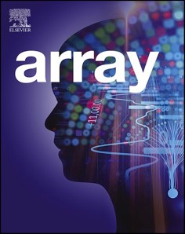[Array 15 (2022) 100242](https://doi.org/10.1016/j.array.2022.100242)

Contents lists available at [ScienceDirect](http://www.sciencedirect.com/science/journal/25900056)

Array

journal homepage: [www.sciencedirect.com/journal/array](https://www.sciencedirect.com/journal/array)

Post-quantum cryptography Algorithm’s standardization and performance analysis

Manish Kumar

*Department of Master of Computer Applications, M S Ramaiah Institute of Technology, Bangalore, 54, India*

A R T I C L E I N F O

*Keywords:*

Quantum cryptography Code based cryptography

Multivariate quadratic equations based cryptography

Hash-based cryptography Isogeny based cryptography Lattice-based cryptography

A B S T R A C T

-Quantum computer is no longer a hypothetical idea. It is the world’s most important technology and there is a

race among countries to get supremacy in quantum technology. It is the technology that will reduce the computing time from years to hours or even minutes. The power of quantum computing will be a great support for the scientific community. However, it raises serious threats to cybersecurity. Theoretically, all the cryptog- raphy algorithms are vulnerable to attack. The practical quantum computers, when available with millions of qubits capacity, will be able to break nearly all modern public-key cryptographic systems. Before the quantum

computers arrive with sufficient ‘qubit’ capacity, we must be ready with quantum-safe cryptographic algorithms,

tools, techniques, and deployment strategies to protect the ICT infrastructure. This paper discusses in detail the global effort for the design, development, and standardization of various quantum-safe cryptography algorithms along with the performance analysis of some of the potential quantum-safe algorithms. Most quantum-safe al- gorithms need more CPU cycles, higher runtime memory, and a large key size. The objective of the paper is to analyze the feasibility of the various quantum-safe cryptography algorithms.

# Introduction

Cryptography is one of the most important pillars of cybersecurity. Cryptography is an art of rendering techniques and the science of securing the information, where the information can be interpreted only by the sender and intended recipient. Most modern cryptography algo- rithms are based on complex mathematical functions. The design of cryptographic algorithms is based on assumptions of computational difficulty. These are asymmetrical problems, such as integer factoriza- tion: multiplying two integers is straightforward, but factoring a 1000- digit integer is difficult.

A form of cryptography that uses two related keys, a public key, and a private key; the two keys have the property that, given the public key, it is computationally infeasible to derive the private key. Current public- key encryption relies on the fact that a classical computer can easily multiply large prime numbers but requires thousands of years to reverse such a calculation. Quantum computing will accelerate the ability to decrypt information protected by current public-key encryption techniques.

Quantum computing is a technology based on the principles of quantum theory which is much faster than classical computing tech- niques. The classical cryptography algorithms are completely vulnerable

to quantum computers. Transitioning to the quantum computer will make the existing IT infrastructure completely unsafe and it requires the design and development of quantum-safe or quantum-resistant cryp- tography algorithms. The objective of this paper is to discuss various cryptography techniques and potential quantum-safe cryptography al- gorithms along with the performance analysis of the algorithms.

The paper is divided into eight sections. Section 2 gives general in- formation about cryptography followed by Section 3 introducing quantum computers. Section 4 discusses the post-quantum encryption problem. Many countries and professional organizations are putting effort to standardize the quantum-safe algorithms which are discussed in Section 5. The National Institute of Standards and Technology (NIST) has initiated an intensive process to standardize the post-quantum encryption algorithm. Some of the potential quantum-safe algorithms which are announced by the NIST in 3rd round of the selection process have been discussed in Section 6 along with the performance analysis of the algorithms based on the Open Quantum Safe (OQS) project imple- mentation. The overall observation, implementation feasibility, and migration challenges are discussed in Section 7 followed by a concluding remark in Section 8.

*E-mail address:* [manishkumarjsr@yahoo.com](mailto:manishkumarjsr@yahoo.com).

<https://doi.org/10.1016/j.array.2022.100242>

Received 2 April 2022; Received in revised form 4 August 2022; Accepted 4 August 2022

Available online 18 August 2022

2590-0056/© 2022 The Author(s). Published by Elsevier Inc. This is an open access article under the CC BY-NC-ND license ([http://creativecommons.org/licenses/by-](http://creativecommons.org/licenses/by-nc-nd/4.0/) [nc-nd/4.0/](http://creativecommons.org/licenses/by-nc-nd/4.0/)).

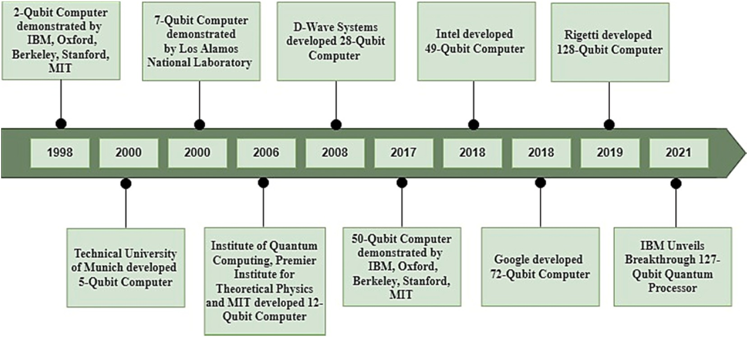

**Fig. 1.** Quantum computing growth in qubits between 1998 and 2021.

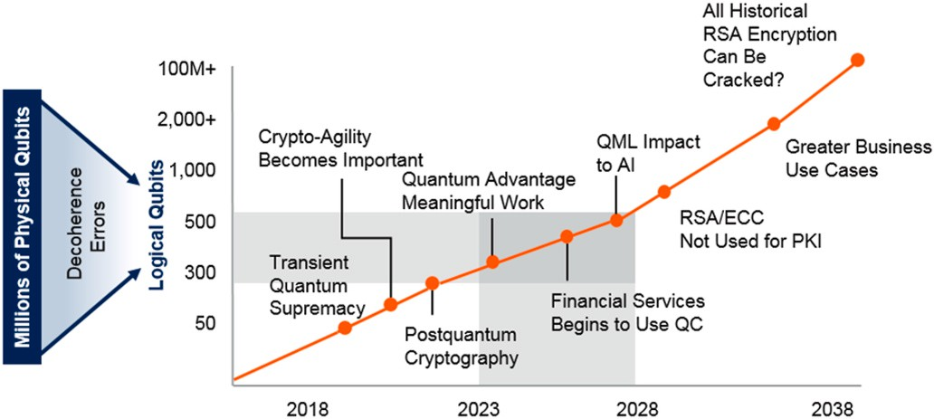

**Fig. 2.** Qubit Timeline Estimate (Source Gartner [83]).

# Cryptography –the building blocks of information security

Today, information security without cryptography is unimaginable thought. Cryptography is used in various ways to protect the confiden- tiality and integrity of the information. Information security hardware and software products implement cryptography in many creative ways with the sole purpose of providing security. Cryptographic algorithms

are well-defined procedures or sequences of rules or steps, or a series of mathematical equations used to describe cryptographic processes such as encryption/decryption, key generation, authentication, signatures, etc. [31].

Cryptographic algorithms are broadly classified into two categories i. e., Symmetric Cryptographic algorithms and Asymmetric Cryptographic Algorithms.

1. **Symmetric Cryptography Algorithms:** In symmetric cryptography algorithms, the sender and receiver use the same key to encrypt and decrypt the data. Symmetric key algorithms are very efficient and easy to implement. However, key management in symmetric cryp- tography is a challenging issue. The key must be shared among the two parties before initiating the communication. Symmetric ciphers are mainly susceptible to chosen-plaintext attack, known-plaintext attack, linear cryptanalysis, and differential cryptanalysis.
2. **Asymmetric Cryptography Algorithm:** In an asymmetric cryptog- raphy algorithm, the sender and receiver use a pair of keys. One of the keys is kept secret i.e., called a private key and the other key is made public called the public key. An asymmetric cryptography al- gorithm is also known as a public-key algorithm. The sender encrypts the data using the public key and the receiver decrypts the data using

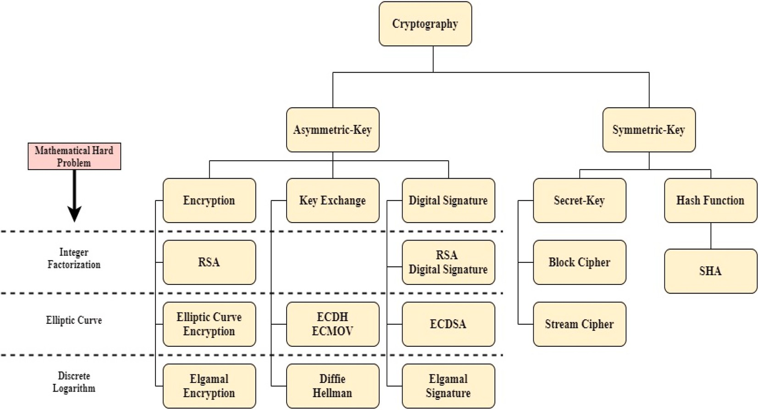

**Fig. 3.** Cryptography branches and the associated mathematical problems.

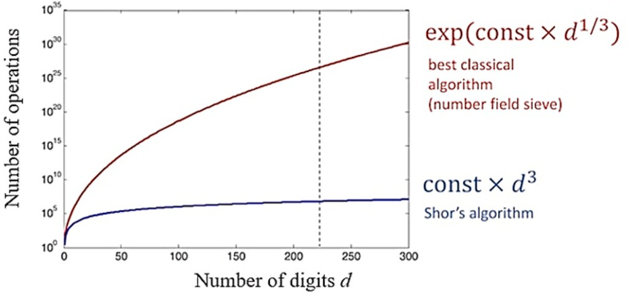

**Fig. 4.** Performance of classical vs. Quantum algorithms for prime number factorization.

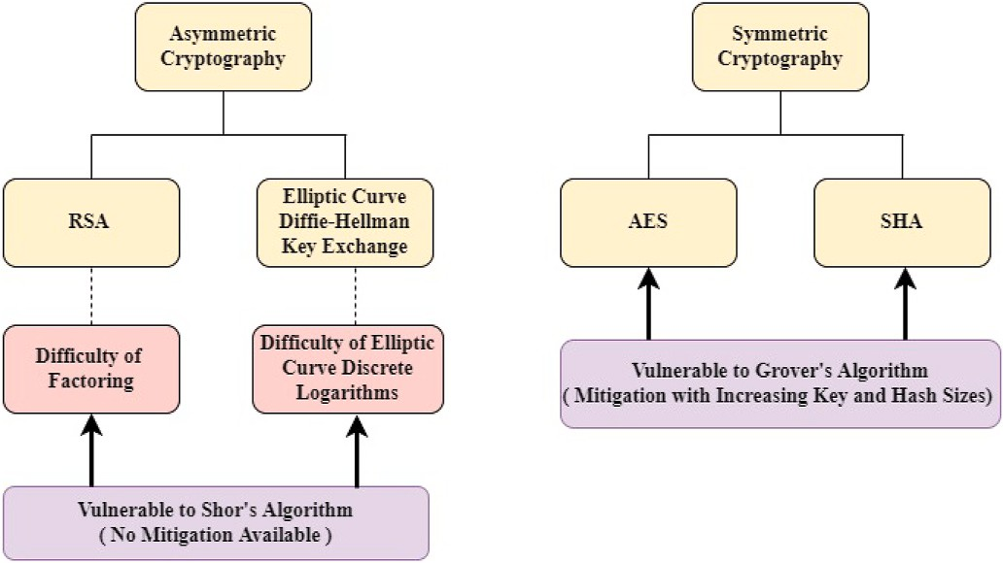

**Fig. 5.** Effect of Shor’s and Grover’s algorithms on Cryptography Algorithm.

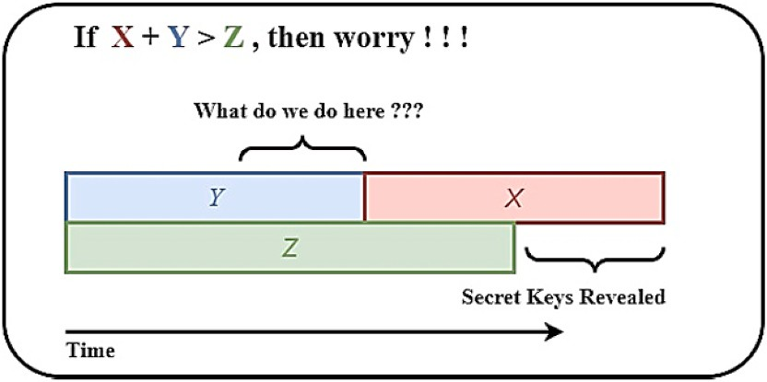

**Fig. 6.** Theorem (Mosca).

**Table 1**

Impact of quantum computing on common cryptographic algorithms.

security services. The public-key ciphers are mainly vulnerable to chosen-ciphertext attacks, man-in-the-middle attacks, and some specific attacks related to the underlying hard problems.

Symmetric and asymmetric, both the algorithms are vulnerable to brute force attack [35,75]. In a brute force attack, the attacker tries all the possible keys. The resistance of the algorithms depends on the key size and computational power required to generate and apply all the possible keys to break the encryption [22,81,84].

Cryptography does not only secure the data but is also used for confidentiality, authentication, integrity, and accessibility. There are various implementations of cryptography algorithms in our daily life. For example, the use of SSL/TLS to provide secure internet browsing, digital signature for authentication and validation, electronic money transactions, secure data storage, etc. [26,55,58].

The concept of a “computationally secure scheme” is that it is theoretically possible to crack such a system, but practically impossible

to do so. The balance is simple to comprehend: if breaking a system costs more than the value it protects, then doing so is pointless. The strength of any cryptography algorithm depends on the computational time and effort required to break the algorithm. Cryptanalysis and brute force techniques are commonly used for breaking the cryptography algorithm. Cryptanalysis is the science of breaking cryptography using mathematics and algorithms. Brute force means that you enumerate overall possi- bilities until you find the solution you were searching for. The cryp- tography algorithm assumes to be secure if it is proven mathematically that to break the algorithm, requires huge computational resources and time which is practically not feasible.

There is continuous growth in computational power and accordingly, the cryptography algorithms are also modified to maintain the strength. Most of the cryptography algorithms used today are resilient against a classical computer. A Quantum computer is new computation technol- ogy that is completely different than a classical computer. A Quantum computer is much faster than a classical computer.

Quantum computing is the next revolutionary technology. It is the technology that will have the ability to reduce the computing time from years to hours or even minutes. The power of quantum computing will be a great support for the scientific community. However, it raises serious cybersecurity threats. Most of the existing cryptography algo- rithms are theoretically vulnerable to quantum computing. A practical quantum computer with sufficient numbers of qubits will be able to break all the modern public-key cryptographic systems [16].

# Quantum computing

A Quantum computer is no longer a hypothetical idea. As quoted by many experts, it is the world’s most important technology and there is a race among countries to get supremacy in quantum technology with a

Cryptographic Algorithm

Type Purpose Impact from Large Scale Quantum Computer

quantum computer of a sufficient number of qubits and fault tolerance. US, China, France, the UK, Germany, and Russia are front runners in the race, whereas other countries are putting their best effort to join the

AES Symmetric

Key

Encryption Larger key sizes needed

league. Race to hold control over “Quantum Computing” technology is not only limited to country, it is significantly driven by the top tech-

SHA-2, SHA-3 ————– Hash Functions Larger output

needed

nology giant like Microsoft, IBM, Google, D-Wave, Toshiba, etc.

Quantum computing got popular after the publication of the article

RSA Public Key Signatures, Key establishment

No longer secure

“Simulating Physics with Computer” by American theoretical physicist

ECDSA, ECDH

(Elliptical Curve Cryptography)

DSA (Finite Field Cryptography)

Public Key Signatures, Key

Exchange

Public Key Signatures, Key

Exchange

No longer secure

No longer secure

Feynman [41]. In the article, Feynman suggested the use of quantum

states for calculations.

Quantum computing is an application of a quantum mechanism that uses a quantum phenomenon to perform computation. A Quantum computer is a device that performs quantum computing. It manipulates the states of qubits in a controlled way to perform algorithms.

a private key. Generally, asymmetric cryptography algorithms are resource-intensive and require more processing time and power. Asymmetric cryptography algorithms satisfy the requirements for digital signatures, cryptographic key establishment, and many more

A qubit (or quantum bit) is the quantum-mechanical analogue of a classical bit. In classical computers information is encoded in a bit, where each bit can be either zero or one. In quantum computing, the information is encoded in qubits. The state of the qubits is written as |

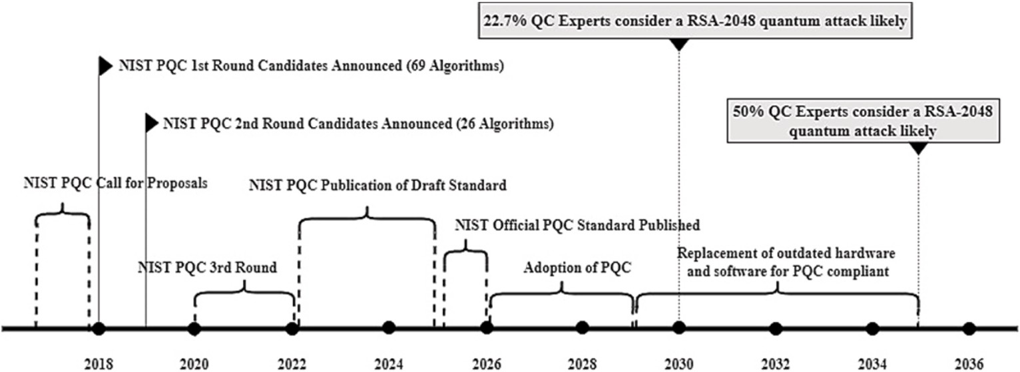

**Fig. 7.** Plausible Timeline for NIST PQC standards development and adoption.

**Table 2**

Code-based quantum-safe cryptographic algorithms.

Sl. No. Algorithm Name Current Status Open-Source C Library for Quantum-Safe Cryptographic Algorithms (liboqs) Usage

|  |  |  |  |  |  |  |  |
| --- | --- | --- | --- | --- | --- | --- | --- |
| 1 | Classic McEliece | Finalists | NIST Level | Algorithms Name | Public Key Size (bytes) | Private Key Size (bytes) |  |
|  |  |  | 1 | Classic-McEliece-348,864 | 261,120 | 6452 | Key Encapsulation Mechanisms |
|  |  |  |  | Classic-McEliece-348864f | 261,120 | 6452 |  |
|  |  |  | 3 | Classic-McEliece-460,896 | 524,160 | 13,568 |  |
|  |  |  |  | Classic-McEliece-460896f | 524,160 | 13,568 |  |
|  |  |  | 5 | Classic-McEliece- | 1,044,992 | 13,892 |  |
|  |  |  |  | 6688,128 |  |  |  |
|  |  |  |  | Classic-McEliece- | 1,044,992 | 13,892 |  |
|  |  |  |  | 6688128f |  |  |  |
|  |  |  |  | Classic-McEliece- | 1,047,319 | 13,908 |  |
|  |  |  |  | 6960,119 |  |  |  |
|  |  |  |  | Classic-McEliece- | 1,047,319 | 13,908 |  |
|  |  |  |  | 6960119f |  |  |  |
|  |  |  |  | Classic-McEliece- | 1,357,824 | 14,080 |  |
|  |  |  |  | 8192,128 |  |  |  |
|  |  |  |  | Classic-McEliece- | 1,357,824 | 14,080 |  |
|  |  |  |  | 8192128f |  |  |  |
| 2 | BIKE | Alternates | 1 | BIKE-L1 | 1541 | 5223 | Key Encapsulation Mechanisms |
|  |  |  | 3 | BIKE-L3 | 3083 | 10,105 |  |
| 3 | HQC | Alternates | 1 | HQC-128 | 2249 | 2289 | Key Encapsulation Mechanisms |
|  |  |  | 3 | HQC-192 | 4522 | 4562 |  |
|  |  |  | 5 | HQC-256 | 7245 | 7285 |  |

**Table 3**

Runtime analysis of open quantum safe code based cryptographic algorithms (Key encapsulation mechanisms).

|  |  |  |  |  |  |  |
| --- | --- | --- | --- | --- | --- | --- |
| Algorithm | Keygen/s | Keygen (cycles) | Encaps/s | Encaps (cycles) | Decaps/s | Decaps (cycles) |
| BIKE-L1 (x86_64) | 4256.67 | 587,177 | 29,602 | 84,291 | 1866.67 | 1,339,145 |
| BIKE-L3 (x86_64) | 1345.33 | 1,858,211 | 14276.33 | 174,889 | 558 | 4,480,077 |
| Classic-McEliece-348,864 (x86_64) | 7.2 | 347,293,159 | 55104.67 | 45,242 | 18448.67 | 135,429 |
| Classic-McEliece-348864f (x86_64) | 9.24 | 270,597,954 | 54,883 | 45,426 | 17712.67 | 141,044 |
| Classic-McEliece-460,896 (x86_64) | 2.42 | 1,032,268,240 | 31683.67 | 78,770 | 7228.33 | 345,779 |
| Classic-McEliece-460896f (x86_64) | 2.91 | 858,376,391 | 31720.33 | 78,686 | 7220.33 | 346,146 |
| Classic-McEliece-6688,128 (x86_64) | 1.56 | 1,604,951,815 | 17,170 | 145,425 | 6163.67 | 405,515 |
| Classic-McEliece-6688128f (x86_64) | 2.2 | 1,137,319,229 | 17034.67 | 146,612 | 6112.67 | 408,895 |
| Classic-McEliece-6960,119 (x86_64) | 1.52 | 1,647,315,912 | 17755.33 | 140,662 | 6705.67 | 372,718 |
| Classic-McEliece-6960119f (x86_64) | 2.36 | 1,058,000,162 | 17,750 | 140,696 | 6655.33 | 375,498 |
| Classic-McEliece-8192,128 (x86_64) | 1.55 | 1,617,672,860 | 14259.33 | 175,108 | 6128 | 407,881 |
| Classic-McEliece-8192128f (x86_64) | 2.13 | 1,176,481,909 | 14550.33 | 171,631 | 6146.67 | 406,618 |
| HQC-128 (x86_64) | 16412.33 | 152,121 | 9847.67 | 253,741 | 5710.67 | 437,665 |
| HQC-192 (x86_64) | 7453.33 | 335,160 | 4283 | 583,564 | 2422.33 | 1,032,052 |
| HQC-256 (x86_64) | 4232.67 | 590,283 | 2430 | 1,028,703 | 1435.33 | 1,741,750 |

0〉 and |1〉. The qubits can be simultaneously both at 0 and 1. Quantum

mechanism is a strange phenomenon. Quantum computers are built using the following features of quantum states:

1. **Superposition:** Quantum systems can exist in two states at once. A qubit can be in 0 and 1 at the same time. When the measure- ment is performed, the qubit collapses to either zero or one.
2. **Entanglement:** It is a quantum mechanical phenomenon where the state of entangled particles can be described with reference to each other. Measurement performed on one entangled particle will immediately influence the other entangled particle irre- spective of the distance among the entangled particle.
3. **Interference:** The fundamental idea in quantum computing is to control the probability of qubits collapsing into a particular measurement state. Quantum interference, a by-product of

**Table 4**

Memory Use Analysis (bytes per algorithm) of Open Quantum Safe Code Based Cryptographic Algorithms (Key Encapsulation Mechanisms).

|  |  |  |  |  |  |  |
| --- | --- | --- | --- | --- | --- | --- |
| Algorithm | Keygen (maxHeap) | Keygen (maxStack) | Encaps (maxHeap) | Encaps (maxStack) | Decaps (maxHeap) | Decaps (maxStack) |
| BIKE-L1 (x86_64) | 11,420 | 90,552 | 12,545 | 25,720 | 12,577 | 73,464 |
| BIKE-L3 (x86_64) | 17,844 | 179,448 | 20,511 | 50,296 | 20,543 | 144,952 |
| Classic-McEliece-348,864 (x86_64) | 271,748 | 2,205,032 | 276,556 | 3824 | 271,940 | 43,232 |
| Classic-McEliece-348864f (x86_64) | 271,748 | 2,205,032 | 276,556 | 3824 | 271,940 | 43,232 |
| Classic-McEliece-460,896 (x86_64) | 541,904 | 4,768,360 | 546,772 | 6528 | 542,156 | 80,256 |
| Classic-McEliece-460896f (x86_64) | 541,904 | 4,768,360 | 546,772 | 6528 | 542,156 | 80,256 |
| Classic-McEliece-6688,128 (x86_64) | 1,063,060 | 4,768,840 | 1,067,980 | 6320 | 1,063,364 | 94,144 |
| Classic-McEliece-6688128f (x86_64) | 1,063,060 | 4,768,840 | 1,067,980 | 6320 | 1,063,364 | 94,144 |
| Classic-McEliece-6960,119 (x86_64) | 1,065,403 | 4,768,808 | 1,070,309 | 6224 | 1,065,693 | 80,896 |
| Classic-McEliece-6960119f (x86_64) | 1,065,403 | 4,768,808 | 1,070,309 | 6224 | 1,065,693 | 80,896 |
| Classic-McEliece-8192,128 (x86_64) | 1,376,080 | 4,769,000 | 1,376,080 | 384 | 1,376,384 | 133,408 |
| Classic-McEliece-8192128f (x86_64) | 1,376,080 | 4,769,000 | 1,376,080 | 384 | 1,376,384 | 133,408 |
| HQC-128 (x86_64) | 8714 | 40,120 | 13,259 | 53,720 | 13,323 | 62,872 |
| HQC-192 (x86_64) | 13,260 | 79,640 | 22,350 | 107,000 | 22,414 | 125,304 |
| HQC-256 (x86_64) | 18,706 | 182,040 | 33,239 | 226,200 | 33,303 | 255,704 |

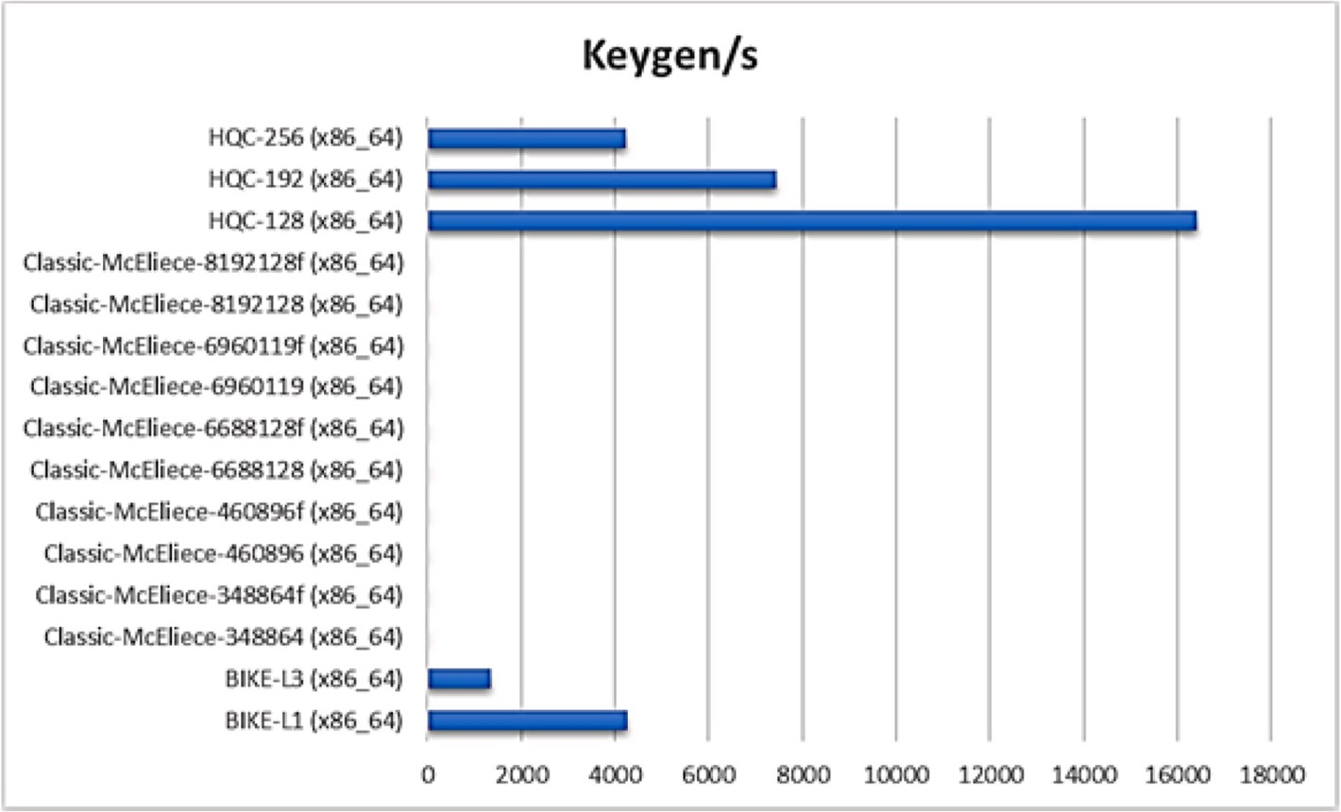

**Fig. 8.** Keygen operations per second per algorithm (Key Encapsulation Mechanisms using Code Based Algorithms).

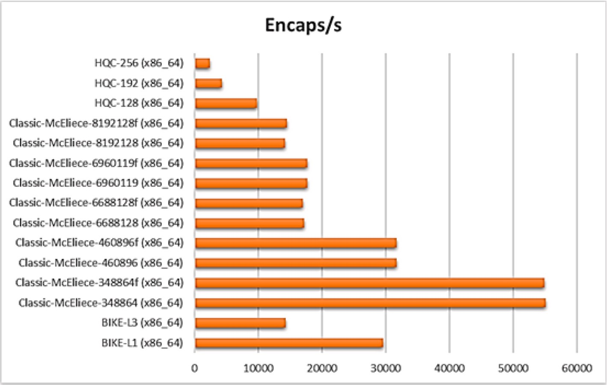

**Fig. 9.** Encaps operations per second per algorithm (Key Encapsulation Mechanisms using Code Based Algorithms).

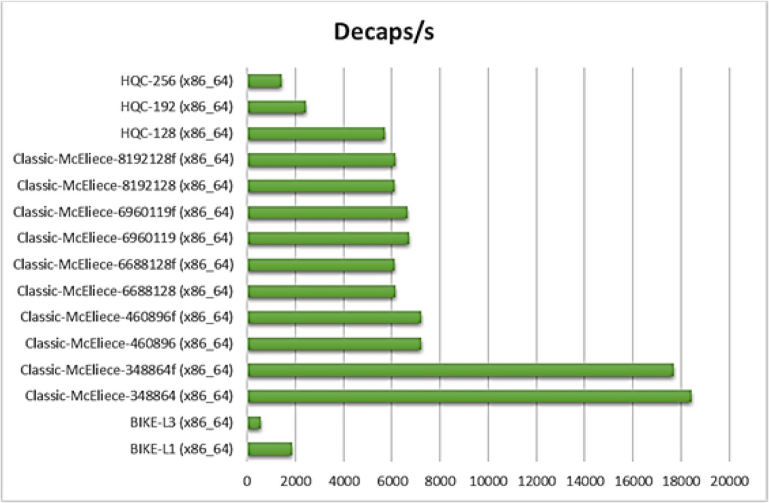

**Fig. 10.** Decaps operations per second per algorithm (Key Encapsulation Mechanisms using Code Based Algorithms).

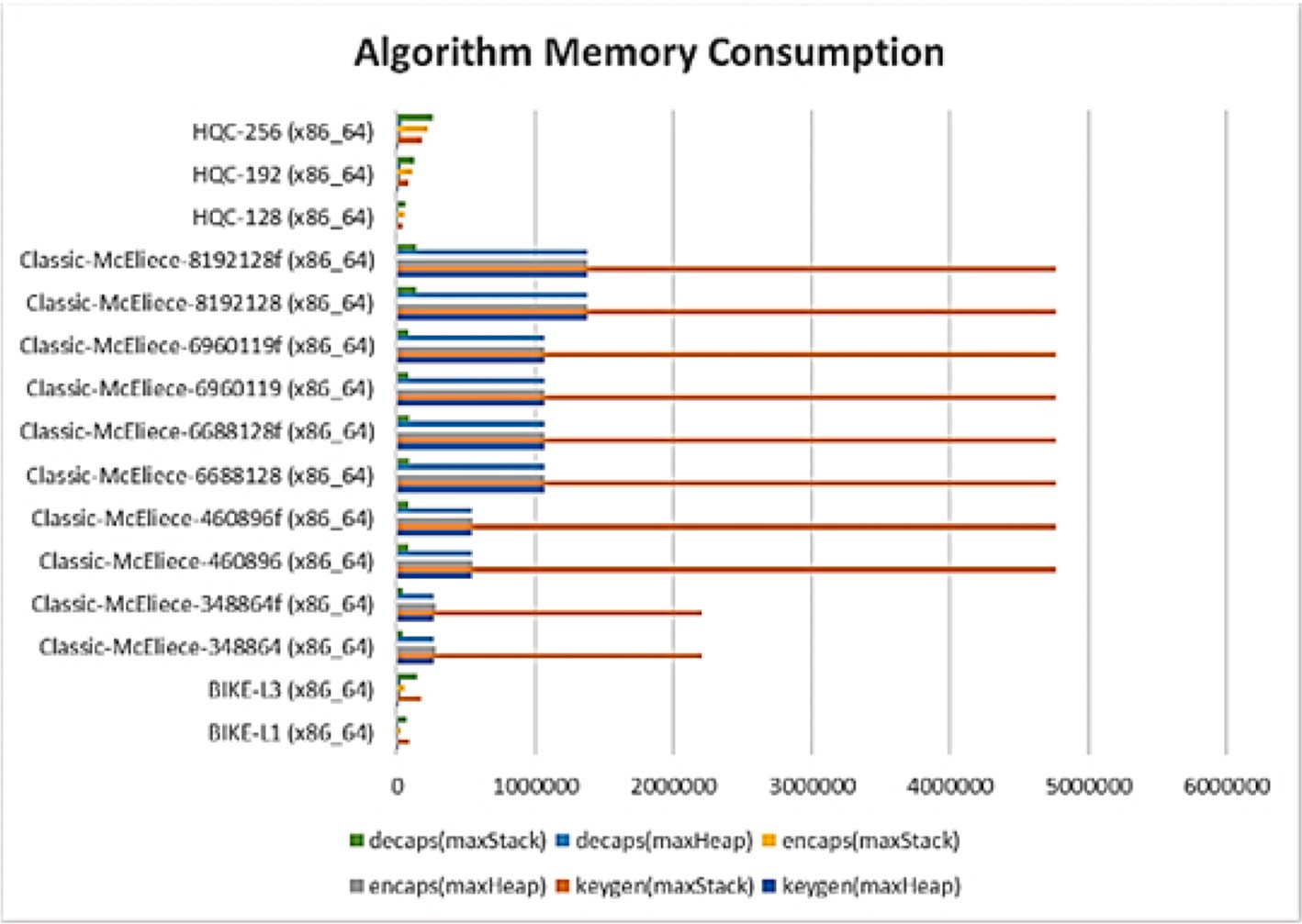

**Fig. 11.** Memory consumption (bytes per algorithm)(Key Encapsulation Mechanisms using Code Based Algorithms).

superposition, allows controlling the measurement of a qubit toward a desired state or set of states.

* 1. *The timescale of quantum computing development*

The quantum computing field is growing rapidly. Globally there is exponential growth in this field. Building a quantum computer with higher qubits and precise error control is the sole objective of the re- searchers. There are remarkable achievements in the last 22 years in this field (Fig. 1). MIT, Oxford, Berkely, and IBM could develop a 2-qubit quantum computer early in 1998. Google developed a 72-qubit quan- tum computer in 2018. Rigetti in 2019, announced to develop a 128- qubit quantum computer within a year [45,52,57].

The development of the Quantum Computer can be divided into three generation.

* + 1. **First Generation:** The first-generation quantum computers are developed at the early stage for non-commercial use. These models were built for proof of concept with low to medium complexity.
    2. **Second Generation:** Many organizations who got the break- through in their initial research and possessed the necessary hardware infrastructure could develop the quantum computer with a higher number of qubits and complexity. The second- generation quantum computers are solely designed and devel- oped for commercial applications and high-end research focused on improved scalability and speed. These quantum computers

**Table 5**

Multivariate quadratic equations based quantum-safe cryptographic algorithms.

Sl.

Algorithm

Current

Open-Source C Library for Quantum-Safe Cryptographic Algorithms (liboqs) Usage

|  |  |  |  |  |  |  |  |
| --- | --- | --- | --- | --- | --- | --- | --- |
| No. | Name | Status | NIST  Level | Algorithms Name | Public Key Size (bytes) | Private Key Size (bytes) |  |
| 1 | Rainbow | Finalists | 1 | Rainbow-I-Classic | 161,600 | 103,648 | Digital Signature |
|  |  |  |  | Rainbow-I-Circumzenithal | 60,192 | 103,648 | Algorithms |
|  |  |  |  | Rainbow-I-Compressed | 60,192 | 64 |  |
|  |  |  | 3 | Rainbow–III–Classic | 882,080 | 626,048 |  |
|  |  |  |  | Rainbow–III–Circumzenithal | 264,608 | 626,048 |  |
|  |  |  |  | Rainbow–III–Compressed | 264,608 | 64 |  |
|  |  |  | 5 | Rainbow-V-Classic | 1,930,600 | 1,408,736 |  |
|  |  |  |  | Rainbow-V-Circumzenithal | 536,136 | 1,408,736 |  |
|  |  |  |  | Rainbow-V-Compressed | 536,136 | 64 |  |
| 2 | GeMSS | Alternates | 1 | N/A (No implementation by Open Quantum Safe | 352,180 | 32 | Digital Signature |
|  |  |  | 3 | Project) |  |  | Algorithms |
|  |  |  | 5 |  |  |  |  |

**Table 6**

Runtime analysis of open quantum safe multivariate quadratic equations based cryptographic algorithms (digital signature algorithms).

|  |  |  |  |  |  |  |
| --- | --- | --- | --- | --- | --- | --- |
| Algorithm | Keypair/s | Keypair (cycles) | Sign/s | Sign (cycles) | Verify/s | Verify (cycles) |
| Rainbow-I-Circumzenithal (x86_64) | 6.06 | 412,509,871 | 530.3 | 4,714,048 | 445.7 | 5,609,619 |
| Rainbow-I-Classic (x86_64) | 6.77 | 369,413,745 | 506 | 4,940,751 | 500.7 | 4,993,923 |
| Rainbow-I-Compressed (x86_64) | 6.02 | 415,229,320 | 13.77 | 181,591,225 | 445.9 | 5,607,001 |
| Rainbow–III–Circumzenithal (x86_64) | 0.43 | 1,535,117,154 | 54.95 | 45,496,023 | 49.06 | 50,968,436 |
| Rainbow–III–Classic (x86_64) | 0.49 | 815,304,452 | 54.82 | 45,599,192 | 50.58 | 49,426,107 |
| Rainbow–III–Compressed (x86_64) | 0.43 | 1,526,552,696 | 0.92 | 2,709,509,453 | 49.2 | 50,814,366 |
| Rainbow-V-Circumzenithal (x86_64) | 0.15 | 3,612,623,138 | 24.87 | 100,519,687 | 22.36 | 111,796,728 |
| Rainbow-V-Classic (x86_64) | 0.17 | 1,503,271,522 | 23.78 | 105,150,930 | 24.24 | 103,104,686 |
| Rainbow-V-Compressed (x86_64) | 0.15 | 3,653,272,908 | 0.32 | 3,503,174,534 | 21.43 | 116,636,792 |

**Table 7**

Memory Use Analysis (bytes per algorithm) of Open Quantum Safe Multivariate Quadratic Equations Based Cryptographic Algorithms (Digital Signature Algorithms).

|  |  |  |  |  |  |  |  |  |  |  |  |  |
| --- | --- | --- | --- | --- | --- | --- | --- | --- | --- | --- | --- | --- |
| Algorithm | Keygen |  | Keygen |  | Sign |  | Sign |  | Verify |  | Verify |  |
|  | (maxHeap) |  | (maxStack) |  | (maxHeap) |  | (maxStack) |  | (maxHeap) |  | (maxStack) |
| Rainbow-I-Circumzenithal (x86_64) | 168,008 |  | 142,440 |  | 172,822 |  | 912 |  | 168,174 |  | 324,056 |  |
| Rainbow-I-Classic (x86_64) | 269,416 |  | 178,680 |  | 274,230 |  | 912 |  | 274,230 |  | 912 |  |
| Rainbow-I-Compressed (x86_64) | 64,424 |  | 246,104 |  | 64,590 |  | 224,504 |  | 64,590 |  | 324,056 |  |
| Rainbow–III–Circumzenithal (x86_64) | 894,824 |  | 946,696 |  | 895,088 |  | 13,464 |  | 895,088 |  | 1,765,144 |  |
| Rainbow–III–Classic (x86_64) | 1,512,296 |  | 993,416 |  | 1,512,832 |  | 15,008 |  | 1,512,296 |  | 384 |  |
| Rainbow–III–Compressed (x86_64) | 268,840 |  | 1,572,760 |  | 269,104 |  | 1,302,104 |  | 269,104 |  | 1,765,144 |  |
| Rainbow-V-Circumzenithal (x86_64) | 1,949,040 |  | 2,208,248 |  | 1,949,352 |  | 22,024 |  | 1949352 |  | 3862296 |  |
| Rainbow-V-Classic (x86_64) | 3,343,504 |  | 2193512 |  | 3343504 |  | 384 |  | 3343504 |  | 384 |  |
| Rainbow-V-Compressed (x86_64) | 540,368 |  | 3617000 |  | 540,680 |  | 2901304 |  | 540,680 |  | 3862296 |  |

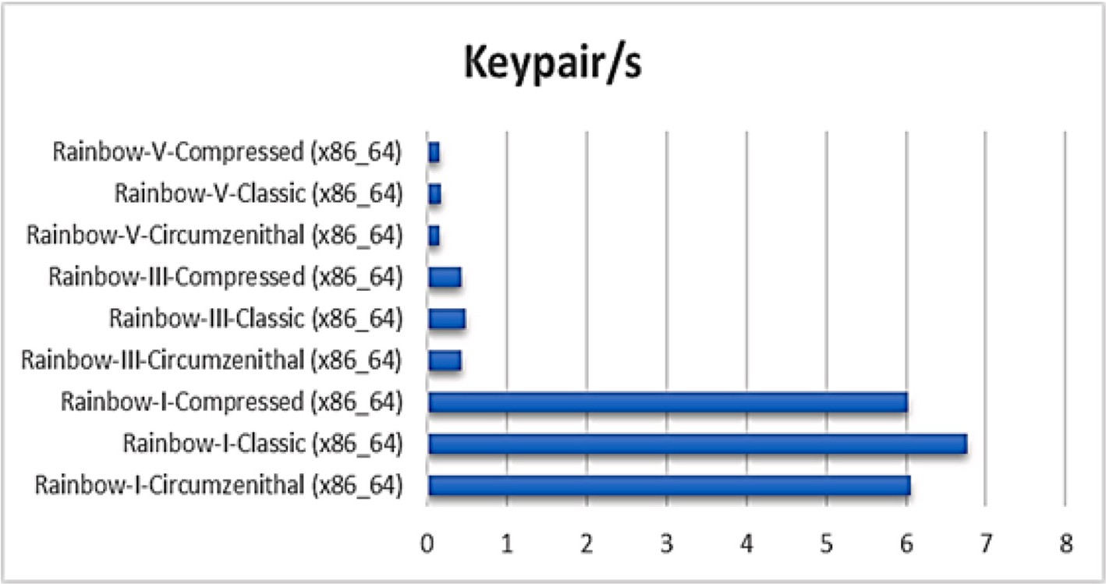

**Fig. 12.** Keypair operations per second per algorithm (Digital Signature using Multivariate Quadratic Equations Based Algorithms).

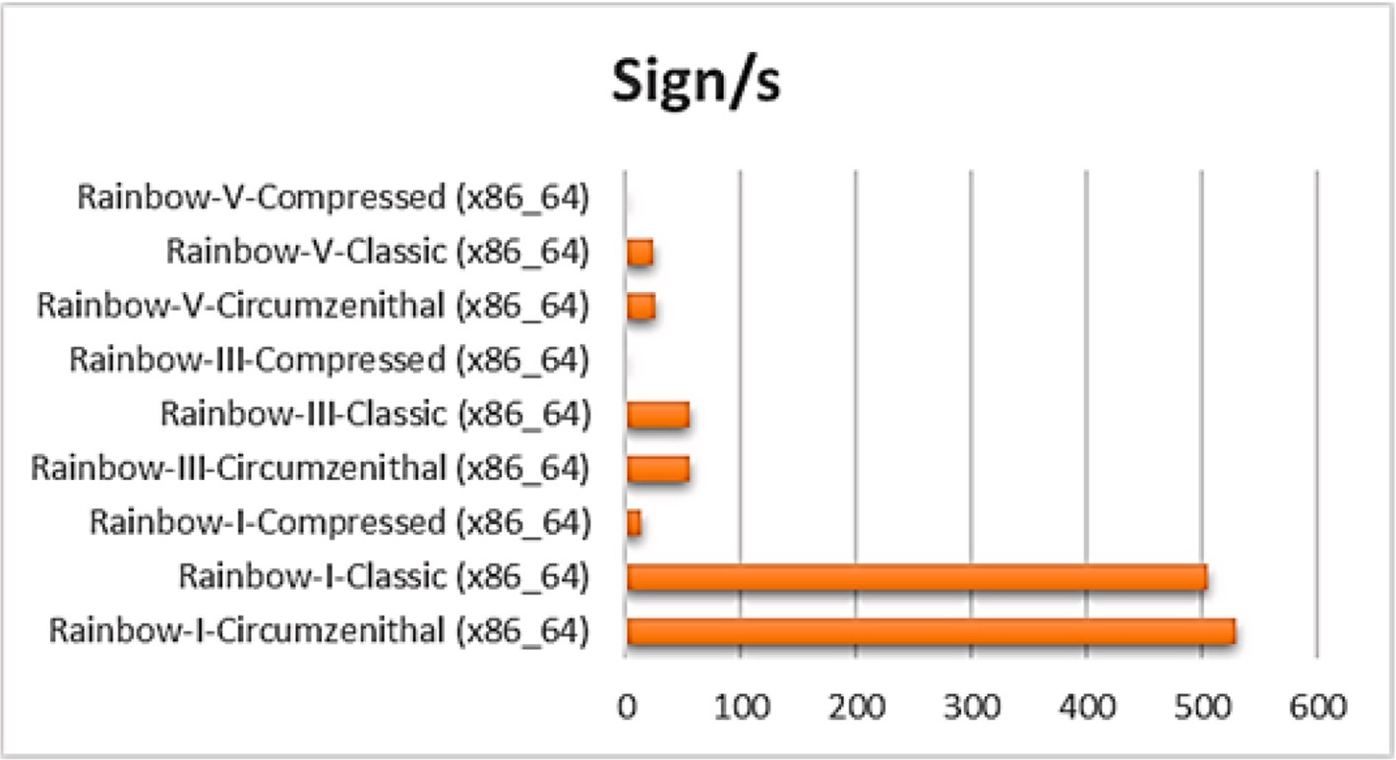

**Fig. 13.** Sign operations per second per algorithm (Digital Signature using Multivariate Quadratic Equations Based Algorithms).

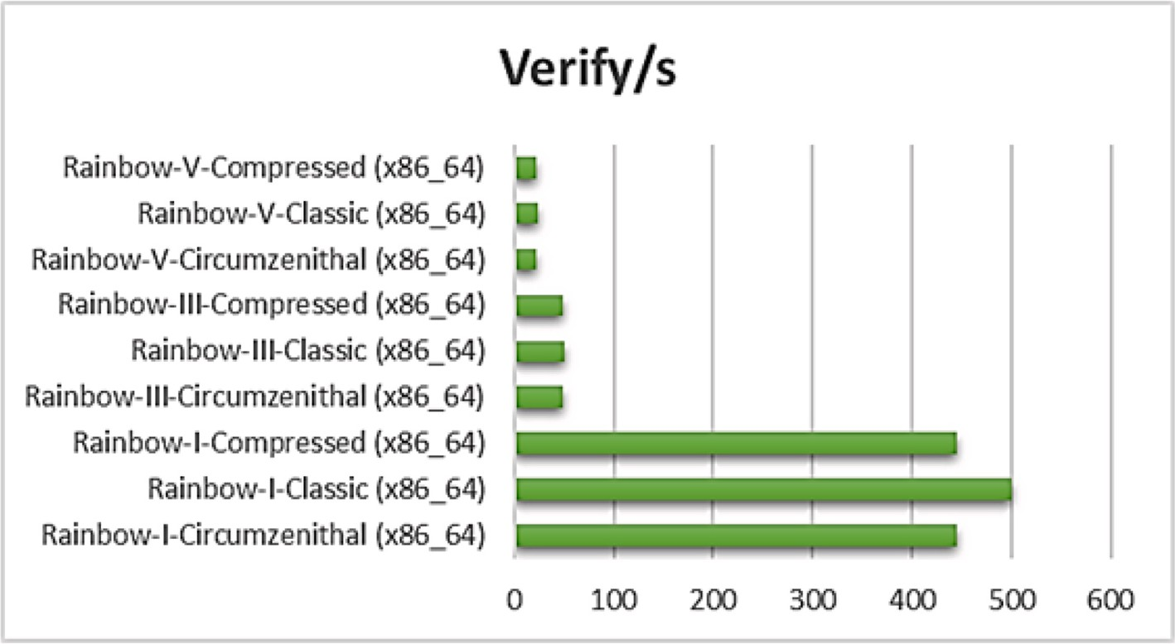

**Fig. 14.** Verify operations per second per algorithm (Digital Signature using Multivariate Quadratic Equations Based Algorithms).

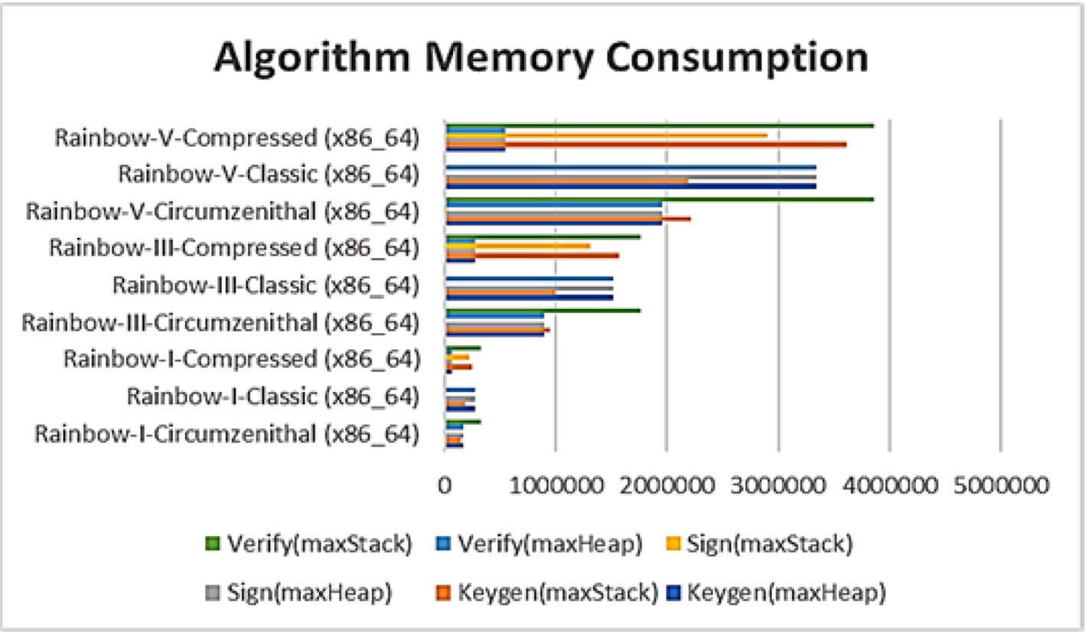

**Fig. 15.** Memory consumption (bytes per algorithm) (Digital Signature using Multivariate Quadratic Equations Based Algorithms).

Hash-based quantum-safe cryptographic algorithms.

Sl.

Algorithm

Current

Open-Source C Library for Quantum-Safe Cryptographic Algorithms (liboqs) Usage

No.

Name

Status

NIST

Level

Algorithms Name Public Key Size (bytes)

Private Key Size (bytes)

1 SPHINCS+ Alternates 1 SPHINCS+-Haraka-128f-robust 32 64 Digital Signature

SPHINCS+-Haraka-128f-simple 32 64

SPHINCS+-Haraka-128s-robust 32 64

SPHINCS+-Haraka-128s-simple 32 64

SPHINCS+-SHA256-128f-robust 32 64

SPHINCS+-SHA256-128f-simple 32 64

SPHINCS+-SHA256-128s-robust 32 64

SPHINCS+-SHA256-128s-simple 32 64

Algorithms

SPHINCS+-SHAKE256-128f-

robust

SPHINCS+-SHAKE256-128f-

simple

SPHINCS+-SHAKE256-128s-

robust

SPHINCS+-SHAKE256-128s-

simple

32 64

32 64

32 64

32 64

3 SPHINCS+-Haraka-192f-robust 48 96

SPHINCS+-Haraka-192f-simple 48 96

SPHINCS+-Haraka-192s-robust 48 96

SPHINCS+-Haraka-192s-simple 48 96

SPHINCS+-SHA256-192f-robust 48 96

SPHINCS+-SHA256-192f-simple 48 96

SPHINCS+-SHA256-192s-robust 48 96

SPHINCS+-SHA256-192s-simple 48 96

SPHINCS+-SHAKE256-192f-

robust

SPHINCS+-SHAKE256-192f-

simple

SPHINCS+-SHAKE256-192s-

robust

SPHINCS+-SHAKE256-192s-

simple

48 96

48 96

48 96

48 96

5 SPHINCS+-Haraka-256f-robust 64 128

SPHINCS+-Haraka-256f-simple 64 128

SPHINCS+-Haraka-256s-robust 64 128

SPHINCS+-Haraka-256s-simple 64 128

SPHINCS+-SHA256-256f-robust 64 128

SPHINCS+-SHA256-256f-simple 64 128

SPHINCS+-SHA256-256s-robust 64 128

SPHINCS+-SHA256-256s-simple 64 128

SPHINCS+-SHAKE256-256f-

robust

SPHINCS+-SHAKE256-256f-

simple

SPHINCS+-SHAKE256-256s-

robust

SPHINCS+-SHAKE256-256s-

simple

64 128

64 128

64 128

64 128

can be rented out for higher computing demand just like cloud computing to serve on a demand basis.

* + 1. **Third Generation:** Third generation will be true quantum su- premacy as the exponential growth and development will bring down the hardware cost. The quantum computer will be afford- able and easily accessible to the mass. The third-generation quantum computer will bring the viable solution across a wide variety of non-commercial applications and it will outperform the classical computer and applications.

There are many technological challenges to the development of Quantum Computer with a higher number of qubits. Initially, the breakthrough research in quantum computing was considerably slow and took significant time to realize the working model. However, in the last few years, there is an unprecedented development. Scientists around the world are addressing various challenging issues to develop an affordable quantum computer with higher accuracy [11,48,61]. Gartner in 2018 has published the estimated timeline for physical qubits ca- pacity and quantum computer application in real-life (Fig. 2). If the

Gartner timeline is to be believed, society will witness quantum su- premacy very soon. Though envisioning the future shows a very good achievement for the computation field, it is a sign of a storm for cyber security.

The development of quantum technology is good news for humanity as it will uplift our life. However, it also raises a serious threat to cybersecurity, requiring a change in how we encrypt our data. As per MIT Technology Review highlights, 20 million-qubit quantum com- puters could break a 2048-bit number in a mere 8 h [8]. Though the 20

million-qubit quantum computers currently do not exist, we need to be prepared and stay ahead of the threat. We can’t wait until those powerful quantum computers start breaking our encryption, it will be

too late. It is time to critically analyze the post-quantum threat and prepare accordingly [85,87,90]. We need to identify the research gap and make a strategic plan to breach the gap.

# Post-quantum encryption problem

Encryption algorithms transform the information in such a way that

Runtime analysis of open quantum safe hash based cryptographic algorithms (digital signature algorithms).

Algorithm Keypair/s Keypair Sign/s Sign Verify/s Verify (cycles) (cycles) (cycles)

SPHINCS+-Haraka-128f-robust (x86_64) 3305.33 756,217 130.25 19193087 1841.3 1,357,668

SPHINCS+-Haraka-128f-simple (x86_64) 3021.67 827,241 126.75 19720897 2389.7 1046180

SPHINCS+-Haraka-128s-robust (x86_64) 49.8 50,199,666 6.26 399193532 5109 489,226

SPHINCS+-Haraka-128s-simple (x86_64) 53.95 46336950 6.88 363,156,129 7042 354,926

SPHINCS+-Haraka-192f-robust (x86_64) 2491 1003522 78.92 31672906 1248 2,003,318

SPHINCS+-Haraka-192f-simple (x86_64) 2850 877,072 99.34 25163368 1754.7 1424860

SPHINCS+-Haraka-192s-robust (x86_64) 26.88 92,991,222 2.63 950449292 2971.7 841,268

SPHINCS+-Haraka-192s-simple (x86_64) 30.68 81486323 3.15 794,443,486 3977.3 628,454

SPHINCS+-Haraka-256f-robust (x86_64) 802.67 3114999 36.18 69108207 1203.6 2,076,672

SPHINCS+-Haraka-256f-simple (x86_64) 823.73 3035014 38.42 65055419 1592.1 1569822

SPHINCS+-Haraka-256s-robust (x86_64) 47.11 53,060,953 3.34 748586944 2257.3 1107434

SPHINCS+-Haraka-256s-simple (x86_64) 51.25 48787641 3.93 636,871,172 3061.7 816,421

SPHINCS+-SHA256-128f-robust (x86_64) 962.35 2,597,396 34.83 71789115 216.64 11,537,909

SPHINCS+-SHA256-128f-simple (x86_64) 1833.33 1363722 65.69 38055893 410.73 6,087,008

SPHINCS+-SHA256-128s-robust (x86_64) 15.42 162114391 1.94 1289794883 574.14 4354738

SPHINCS+-SHA256-128s-simple (x86_64) 27.71 90,208,011 3.64 687556446 1228.3 2035202

SPHINCS+-SHA256-192f-robust (x86_64) 676.11 3697467 22.13 112,975,498 144.19 17338755

SPHINCS+-SHA256-192f-simple (x86_64) 1200.33 2082895 38.49 64952624 250.42 9983430

SPHINCS+-SHA256-192s-robust (x86_64) 10.41 240,149,708 1.08 2317742108 399.4 6258715

SPHINCS+-SHA256-192s-simple (x86_64) 18.74 133365900 1.88 1,331,847,740 730.33 3423401

SPHINCS+-SHA256-256f-robust (x86_64) 140.24 17824497 6.67 374615844 108.67 23007612

SPHINCS+-SHA256-256f-simple (x86_64) 450.85 5,544,896 20.81 120145814 272.91 9159588

SPHINCS+-SHA256-256s-robust (x86_64) 8.73 286251953 0.75 3,329,041,447 207.26 12062042

SPHINCS+-SHA256-256s-simple (x86_64) 30.34 82391795 2.4 1043537732 530.33 4,714,332

SPHINCS+-SHAKE256-128f-robust (x86_64) 462.36 5,406,859 18.56 134699425 154.69 16161667

SPHINCS+-SHAKE256-128f-simple (x86_64) 844 2962241 32.16 77,738,565 301.8 8283439

SPHINCS+-SHAKE256-128s-robust (x86_64) 7.81 320,032,253 1.02 2460642112 543.49 4,599,201

SPHINCS+-SHAKE256-128s-simple (x86_64) 13.66 183,072,418 1.71 1463603275 915.67 2730203

SPHINCS+-SHAKE256-192f-robust (x86_64) 331.89 7532419 11.55 216,435,158 119.17 20977226

SPHINCS+-SHAKE256-192f-simple (x86_64) 580.14 4309068 20.11 124327976 229.26 10,905,347

SPHINCS+-SHAKE256-192s-robust (x86_64) 5.2 480506759 0.58 46486796 319.23 7831342

SPHINCS+-SHAKE256-192s-simple (x86_64) 9.35 267,514,170 1 2498600938 655.33 3,814,860

SPHINCS+-SHAKE256-256f-robust (x86_64) 123.63 20220286 5.92 422,251,215 108.78 22981847

SPHINCS+-SHAKE256-256f-simple (x86_64) 220.11 11,357,895 10.37 241136741 209.39 11,937,656

SPHINCS+-SHAKE256-256s-robust (x86_64) 7.5 333331669 0.66 3783521422 227.85 10973738

SPHINCS+-SHAKE256-256s-simple (x86_64) 13.28 188,315,722 1.08 2311104060 427.19 5852661

it is difficult to interpret it unless and until it is decrypted using the decryption key [27,33,86]. Most of the encryption algorithms are based on complex mathematical function (Fig. 3) which is easy to compute in one direction but very difficult to compute in the reverse direction [23, 28]. These algorithms are known as one-way functions. RSA is one of the most commonly used encryption algorithms which makes use of the one-way function.

The core strength of the RSA algorithm is based on prime factor- ization as a method of one-way encryption. The sender uses an encryption key which is generated using the multiplication of two randomly generated large prime numbers. The receiver can decrypt the message, only if knows the exact prime factor. The problem is easy to solve in one direction but difficult to compute in another direction.

Suppose we want to factor an integer *N* with *d* decimal digits. The brute force algorithm goes through all primes *p* up to √̅̅̅̅ and checks

*N*

whether *p* divides *N*. The worst-case time complexity of the brute force algorithm is approximately √̅̅̅̅ , which is exponential in the number of

*N*

digits *d*.

The quadratic sieve algorithm, construct integers *a*, *b* such that *a*2— *b*2 is a multiple of *N*. Once such a combination of *a*, *b* is found, one checks whether have *a b* common factors with *N* . The quadratic sieve is very

±

efficient it has asymptotic runtime complexity in √̅̅̅

*d*. The generic

number field sieve, the most efficient classical factoring technique, achieves an asymptotic runtime exponential in *b*1/3.

The traditional factoring methods’ usefulness is limited to numbers with a few hundred digits due to exponential runtime scaling. Shor’s factoring algorithm, on the other hand, has a runtime polynomial in

d (number of digits). The performance of classical vs. quantum algo- rithms for prime number factorization is shown in Fig. 4 [53].

* 1. *The effect of an algorithm*

In 1994 Peter Shor developed a polynomial-time quantum computer algorithm for integer factorization. It was a major breakthrough to prove

the Quantum Computer’s supremacy over a classical computer [37,46]. Shor’s algorithm will greatly reduce the prime factorization time. All the

encryption algorithm which is based on the assumption that extracting the private key is computationally infeasible with the existing computing resource does not stand.

Successful implementation of Shor’s algorithm could easily break the

most widely used cryptographic algorithm such as RSA, Elliptic Curve Cryptography (ECC), and Diffie-Hellman. These algorithms play a vital role in data protection and privacy. Any possibility to break these al- gorithms is a serious threat and could be devastating [15,21,73]. It will be a direct threat to the information and communication security of individuals, government, and business organizations.

In 1996 Lov Grover developed an algorithm using quantum com- puters to search the unsorted database. Grover’s search algorithm can find an element in the unsorted database of N elements in √*N* searches. The algorithm can search and find the key in very less iterations. For

example, Grover’s search algorithm needs only 185 searches to find the key for the DES algorithm which relies on a 56-bit key [49]. Though Grover’s search algorithm is not so fast as Shor’s algorithm it is a po- tential threat to the symmetric cryptography algorithm. If a Quantum

Computer of sufficient size and fault tolerance is built, then Shor’s al- gorithm will break today’s public-key cryptography. Variants of the algorithm are applied to both the discrete logarithm problem (which

breaks elliptic curve cryptography and finite field Diffie-Hellman) and to factoring large integers (which breaks RSA) (Fig. 5).

**Table 10**

Memory Use Analysis (bytes per algorithm) of Open Quantum Safe Hash-Based Cryptographic Algorithms (Digital Signature Algorithms).

Algorithm Keygen Keygen Sign Sign Verify Verify (maxHeap) (maxStack) (maxHeap) (maxStack) (maxHeap) (maxStack)

SPHINCS+-Haraka-128f-robust (x86_64) 8912 3712 26,100 19,472 26,100 2304

SPHINCS+-Haraka-128f-simple (x86_64) 8912 3712 26,100 19,472 26,100 2304

SPHINCS+-Haraka-128s-robust (x86_64) 8912 2368 16,868 10,240 16,868 2304

SPHINCS+-Haraka-128s-simple (x86_64) 8912 2368 16,868 10,240 16,868 2304

SPHINCS+-Haraka-192f-robust (x86_64) 8960 2432 44,724 38,128 44,724 1960

SPHINCS+-Haraka-192f-simple (x86_64) 8960 2432 44,724 38,128 44,724 1960

SPHINCS+-Haraka-192s-robust (x86_64) 8960 2432 25,284 18,672 25,284 2304

SPHINCS+-Haraka-192s-simple (x86_64) 8960 2432 25,284 18,672 25,284 2304

SPHINCS+-Haraka-256f-robust (x86_64) 9008 2496 58,964 52,352 58,964 1960

SPHINCS+-Haraka-256f-simple (x86_64) 9008 2496 58,964 52,352 58,964 1960

SPHINCS+-Haraka-256s-robust (x86_64) 4360 7400 34,252 38,552 38,900 1960

SPHINCS+-Haraka-256s-simple (x86_64) 4360 7400 34,252 37,800 38,900 1960

SPHINCS+-SHA256-128f-robust (x86_64) 4432 9416 21,620 11,752 26,100 2304

SPHINCS+-SHA256-128f-simple (x86_64) 4432 7560 21,620 9928 26,100 2304

SPHINCS+-SHA256-128s-robust (x86_64) 4432 9640 12,388 12,840 16,868 2304

SPHINCS+-SHA256-128s-simple (x86_64) 4432 7784 12,388 11,016 16,868 2304

SPHINCS+-SHA256-192f-robust (x86_64) 4480 10,536 40,244 14,120 40,412 6816

SPHINCS+-SHA256-192f-simple (x86_64) 4480 8488 40,244 12,072 44,724 1960

SPHINCS+-SHA256-192s-robust (x86_64) 4480 10,856 20,804 15,944 25,284 2304

SPHINCS+-SHA256-192s-simple (x86_64) 4480 8808 20,804 13,896 25,284 2304

SPHINCS+-SHA256-256f-robust (x86_64) 4528 11,944 54,484 16,360 54,652 7840

SPHINCS+-SHA256-256f-simple (x86_64) 4528 9704 54,484 14,152 54,652 7840

SPHINCS+-SHA256-256s-robust (x86_64) 4528 12,200 34,420 18,376 34,588 7840

SPHINCS+-SHA256-256s-simple (x86_64) 4528 9992 34,420 16,168 34,588 6720

SPHINCS+-SHAKE256-128f-robust (x86_64) 8912 2432 26,100 18,192 26,100 2304

SPHINCS+-SHAKE256-128f-simple (x86_64) 8912 2432 26,100 18,192 26,100 2304

SPHINCS+-SHAKE256-128s-robust (x86_64) 8912 2560 13,052 13,128 16,868 2304

SPHINCS+-SHAKE256-128s-simple (x86_64) 8912 2560 13,052 13,064 16,868 2304

SPHINCS+-SHAKE256-192f-robust (x86_64) 8960 2432 40,908 41,608 44,724 1960

SPHINCS+-SHAKE256-192f-simple (x86_64) 8960 2432 40,908 41,608 44,724 1960

SPHINCS+-SHAKE256-192s-robust (x86_64) 8960 2432 21,468 22,888 25,284 2304

SPHINCS+-SHAKE256-192s-simple (x86_64) 8960 2432 21,468 22,888 25,284 2304

SPHINCS+-SHAKE256-256f-robust (x86_64) 9008 2496 55,148 57,000 58,964 1960

SPHINCS+-SHAKE256-256f-simple (x86_64) 9008 2496 55,148 57,000 58,964 1960

SPHINCS+-SHAKE256-256s-robust (x86_64) 5192 6464 35,084 37,800 38,900 1960

SPHINCS+-SHAKE256-256s-simple (x86_64) 5192 6464 35,084 37,800 38,900 1960

* 1. *Sense of urgency*

As described by Dr. Michele Mosca [47], the urgency for any orga- nization to transit to the quantum-resistant or quantum-safe cryptog- raphy depends on the following parameters:

* **Shelf-Life Time (X Years):** Number of years you need your crypto- graphic key to remain secure and your data to be protected.
* **Migration Time (Y Years):** Number of years required to develop,

deploy and migrate to the Quantum-Safe solution.

* **Threat Timeline (Z Years):** The number of years before large-scale quantum computers will be built which can break the current cryp- tography algorithms.

If the Threat Timeline is shorter than the sum of Shelf-Life Time and Migration Time (Fig. 6) i.e. ‘X + Y > Z’ then it is a matter of serious concern as the organizations will not be able to protect their assets for

the required years against quantum attack [5,62,65].

Assessing the exact Threat Timeline (i.e., value for ‘Z’) is a chal- lenging task as there are so many obstacles in building the quantum

computer with a required number of qubits and efficiency. However, the current trend in research and development shows that the days are not far away when we will have quantum computers with the required computation power [9,19,50]. At some point, we can also expect

Moore’s Law to support the scaling up of the development of quantum Computer technology as it happened with conventional computing

technologies.

The threat is not only challenging for future perspective but it is significant today itself [24,88]. It is quite possible that many hackers, state-sponsored or nation-states themselves might be intercepting and

harvesting the encrypted messages with envisioning that they will be able to decrypt these messages when the quantum computing resources

will be available in the future. If today’s private messages get disclosed even in the future, it will have a serious adverse effect on corporates,

government organizations, the military, and the diplomatic relations of countries. So, the threat is not in the future as shown by Mosca Theorem but has already begun from the very first day Shor’s algorithm was

introduced in 1994. Hence, any communication done since 1994 using

an existing cryptography algorithm that is not quantum-safe is vulner- able and can be exposed in the future [7,63].

* 1. *Quantum computing impact on existing cryptography algorithm*

A practical quantum computer with the required number of qubits (millions of qubits) will be able to break all the modern public-key cryptographic systems**.** National Institute of Standards and Technology (NIST) 2016 report on post-quantum cryptography shown in Table 1, highlights the impact of quantum computing on common cryptographic algorithms.

NIST is rigorously working to analyze, test, and validate post- quantum algorithms and is expected to release a draft standard by 2023. The potential algorithms are evaluated on various factors such as robustness against cryptanalysis attacks, algorithm efficiency, interop- erability, implementation feasibility, etc.

# Global initiatives and standardization

The importance of the Quantum-Safe algorithm is well understood by government organizations and IT giants around the world. The threat is real and that day is fast approaching. Hence many countries and

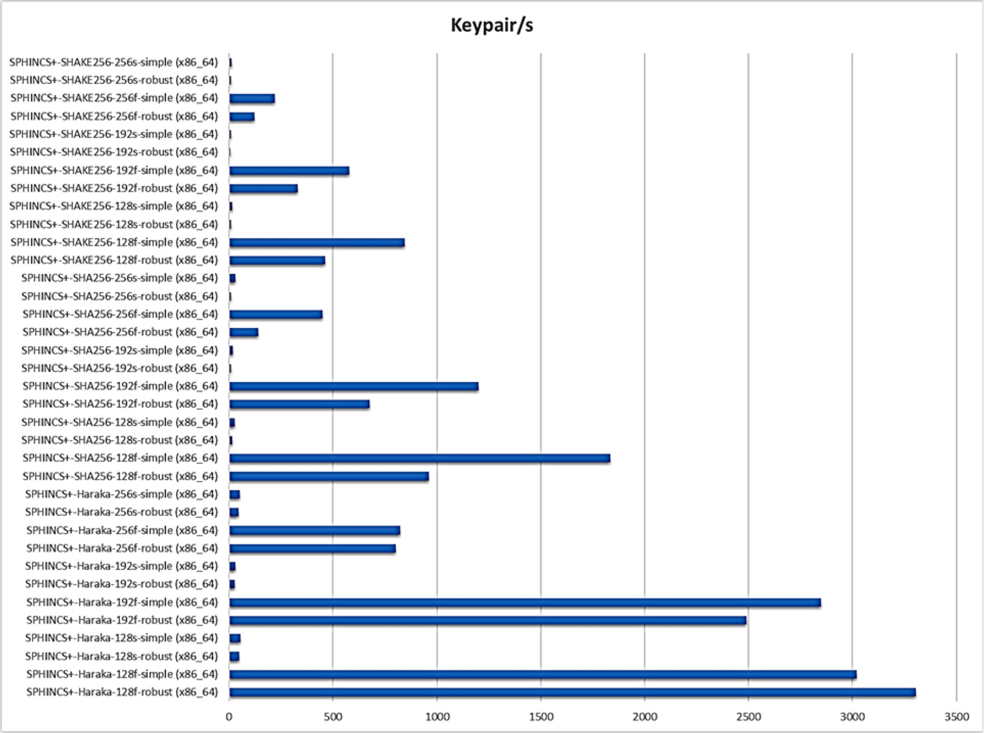

**Fig. 16.** Keypair operations per second per algorithm (Digital Signature using Hash-Based Algorithms).

standard organizations have taken an initiative in the design, develop- ment, testing, and migration strategy for quantum-safe algorithms [56]. The working group, forum, and standard organizations are publishing framework, policy documents, whitepapers, technical details, stan- dardization documents, and cost-effective migration strategies to post-quantum cryptography. Some of the organizations leading the standardization process are:

1. **National Institute of Standards and Technology (NIST) PQC Standardization:** The major initiative has been taken by the National Institute of Standards and Technology (NIST) to solicit, evaluate and standardize the quantum-resistant public-key cryptographic algorithms. The NIST has begun the process in 2016 to determine the criteria and requirements for quantum- safe algorithms and announced the call for proposal [71]. The first round of submissions was announced in 2017 in which 82 submissions were received out of which 69 were announced as 1st round candidates. Analysis for the 1st round of candidates was done in 2018 and 1st NIST QPC standardization conference was held. The 2nd NIST PQC standardization conference was held in the year 2019 and 26 candidates were announced for the 2nd round. The NIST announced 7 finalists and 8 alternate candidates during the 3rd round in the year 2020 [2]. NIST completed the 3rd round process in July 2022. Four algorithms have been selected for standardization and additional four algorithms have been considered for the 4th round of evaluation [3,6]. The

plausible timeline for NIST PQC standards development and adoption is shown in Fig. 7 [77].

1. **The European Telecommunications Standards Institute (ETSI):** The European Telecommunications Standards Institute (ETSI) has a Cyber Quantum-Safe Cryptography (QSC) group, actively working on post-quantum-safe algorithms. The QSC working groups aim to recommend a quantum-safe cryptographic algorithm and its implementation. The focus is on architectural consideration for specific applications, implementation capabil- ities, performance, etc. The group has published cost-effective migration strategies to post-quantum cryptography and some of the challenges and recommendations. ETSI is also organizing workshops on post-quantum cryptography since 2013.
2. **The Internet Engineering Task Force (IETF):** The Internet En- gineering Task Force (IETF) is focused on promoting voluntary internet standards. IETF has Crypto Forum Research Group (CFRG). The CFRG forum bridge the gap between industry and research organizations, bringing new cryptographic techniques to the Internet community and promoting an understanding of the use and applicability of these mechanisms via Informational RFCs. The working group is developing Request for Comment (RFC) protocols compatible with post-quantum cryptography.
3. **The American National Standards Institute (ANSI):** The Accredited Standards Committee X9F which is the subcommittee of the American National Standards Institute (ANSI) has made some recommendations on lattice-based quantum-safe

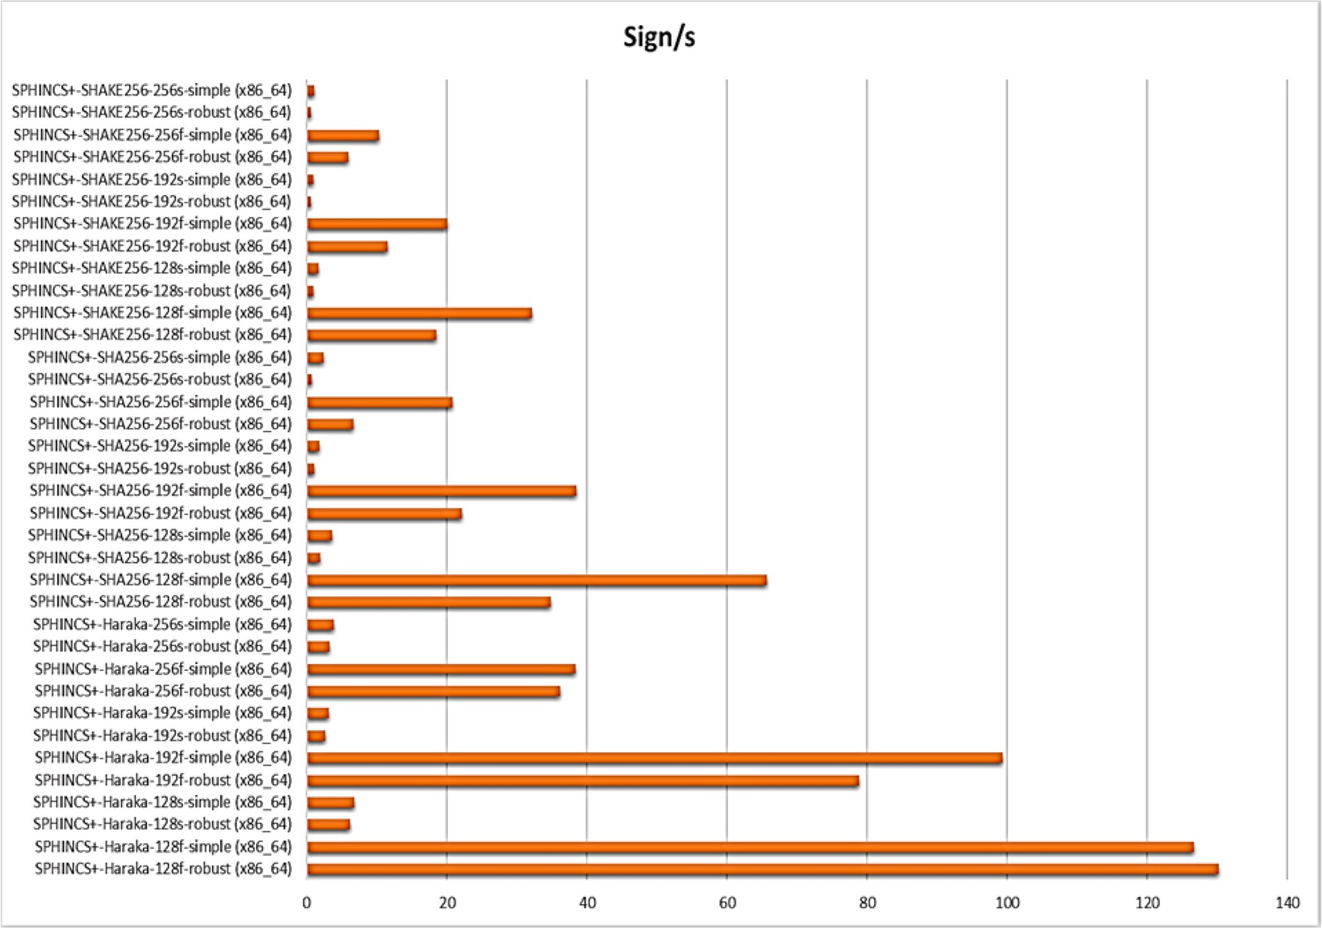

**Fig. 17.** Sign operations per second per algorithm (Digital Signature using Hash-Based Algorithms).

algorithms as far back as 2010. The X9 committee is working actively on methods to minimize or eliminate avenues of attack by quantum computers on the financial services industry. The working group’s objective is to determine what preventive

measures the financial service industry should be taking to pro-

tect against attacks from a large-scale quantum computer and publish periodical reports and whitepapers.

1. **Federal Office for Information Security (BSI):** In order to be prepared for future risk, the German Federal Office for Informa- tion Security, BSI has also released technical guidelines that recommend algorithms, and key lengths and make specific rec- ommendations for Merkle-based signature schemes and XMSS. The focus is the development of quantum-safe public-key cryp- tography algorithms. In 2020 the BSI also developed the initial recommendations for the migration to post-quantum cryptography.

# Potential solution for post quantum encryption challenges

Scientists and research organizations are working very hard to develop and standardize quantum-safe cryptographic algorithms. However, not much information is available in the public domain except for the work done by NIST. The NIST process to solicit, evaluate, and standardize the quantum-resistant cryptographic algorithms is very meticulous, and detailed information is published. Hence, decided to do a comparative analysis of 7 finalists and 8 alternate quantum-resistant algorithms announced by the NIST during the 3rd round in the year 2020. The objective of the analysis is to assess the implementation

feasibility of the prospective algorithms based on their CPU cycle and memory utilization.

The performance analysis of the algorithms is done using the Open Quantum Safe (OQS) project. It is a project, developing and prototyping quantum-resistant cryptography algorithms [4]. OQS has developed “liboqs” which is an open-source library for quantum-resistant crypto-

graphic algorithms. OQS is mainly focused on the NIST Post-Quantum

Cryptography standardization for Key Encryption Mechanisms (KEM) and Signature Schemes. The OQS also provides benchmarking data for various quantum-resistant algorithms which are used in this paper for

the comparative analysis of the algorithm’s runtime behavior and memory consumption. The runtime behavior and memory consumption

data of the algorithms are collected based on the execution of the al- gorithms on Amazon Web Service (AWS) with CPU Model Intel(R) Xeon

(R) Platinum 8259CL CPU @ 2.50 GHz.

* 1. *Code-based cryptography*

The code-based cryptography algorithm (e.g., McEliece) relies on the hardness of decoding in a linear error-correcting code possibly chosen with some particular structure or in a specific family (for instance, quasi-

cyclic codes, or Goppa codes). Classic McEliece, a code-based post- quantum public-key cryptosystem (PKC) contender for NIST’s world- wide standardization, was suggested by Daniel J. Bernstein in 2017 [17, 18,79]*.* In McEliece’s idea, a public key is the product of the Goppa code and the linear transformation. To encrypt the message, the sender needs to add a specific amount of random noise [1,12–14]. The noise can be removed only using the Goppa code [66,70]. It is a computationally

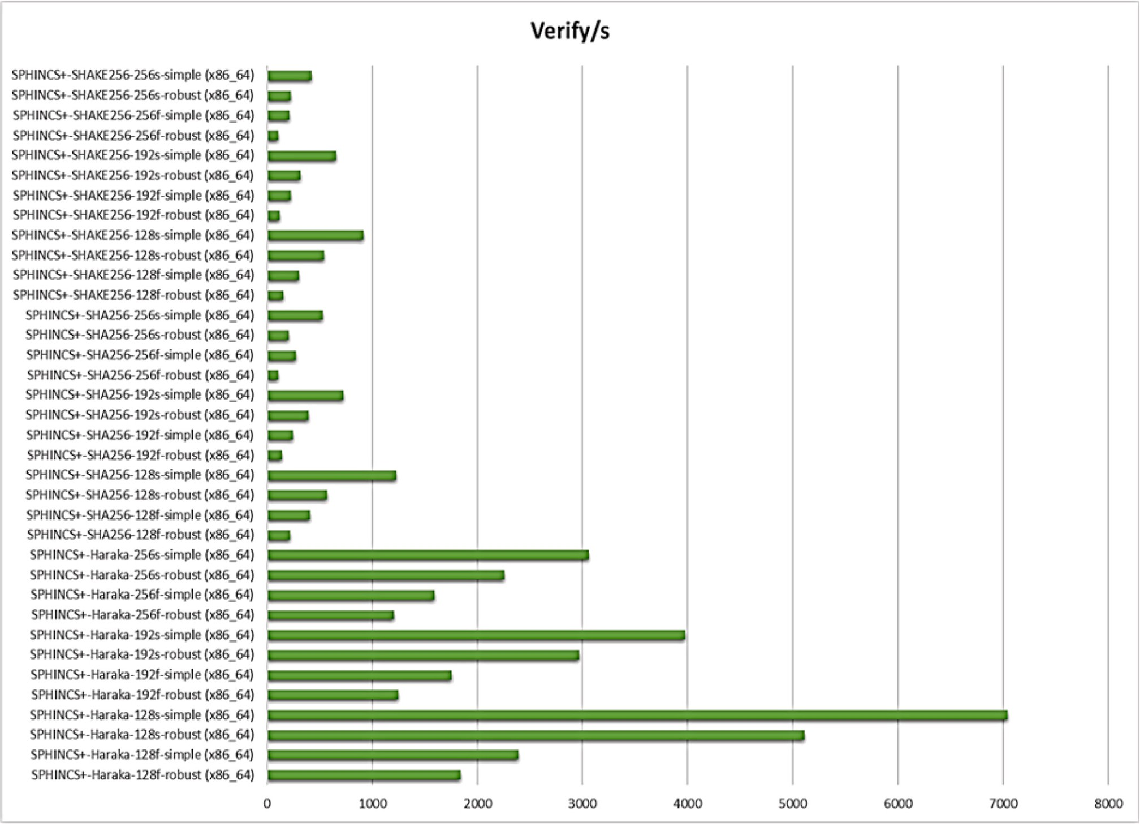

**Fig. 18.** Verify operations per second per algorithm (Digital Signature using Hash-Based Algorithms).

challenging problem for the attacker to recover the message without knowing how to factor in the public key. There are various code-based cryptography algorithms available, among which some potential quantum-safe algorithms are:

* + 1. **Classic McEliece** was introduced by Robert McEliece in 1978. It is a code-based algorithm proposed for the Key Encapsulation Mechanism (KEM). There are very few changes in the algorithm

since it was introduced. The changes in the algorithm’s security parameters are done to increase the computational speeds.

Classic McEliece parameters can be set to match all the five NIST security levels. The computation time of the Classic McEliece algorithm is extremely fast but the algorithms require a very large public key size.

* + 1. **BIKE** (Bit Flipping Key Encapsulation) is a code-based key encapsulation mechanism. It is based on quasi-cyclic moderate density parity-check (QC-MDPC) codes that can be decoded using bit flipping decoding techniques [68]. BIKE can satisfy the NIST security level 1 and 3.
    2. **HQC** (Hamming Quasi-Cyclic) is a code-based public-key algo- rithm designed to provide security against classical and quantum computers. The HQC algorithm is designed to achieve NIST 1, 3, and 5 security levels [51].

Classic McEliece is a round 3 finalist whereas BIKE, and HQC are declared as alternate candidates by NIST (Table 2). Runtime behavior and memory consumptions of Classic MeEliece, BIKE, and HQC are shown in Table 3, Table 4, and graphically represented in Fig. 8, Fig. 9, Fig. 10, and Fig. 11.

* 1. *Multivariate Quadratic Equations based cryptography*

A multivariate quadratic equation-based public key cryptosystem is having a set of quadratic polynomials over a finite field. In some cases, those polynomials could be defined over both grounds and as an extension field. The security of a multivariate public-key cryptosystem is based on the fact that solving the multivariate polynomial equation is proven to be NP-Hard or NP-Complete. Cryptographic algorithms based on Multivariate Quadratic Equations which are potentially quantum- safe are as follows:

1. **Rainbow** algorithms belong to the family of multivariate public-key cryptosystems. It is designed by Jintai Ding and Dieter Schmidt in 2004. The algorithm is based on the Oil-Vinegar signature scheme invented by Jacques Patarin. The algorithm is based on the fact that solving a set of random multivariate quadratic systems is an NP-hard problem [20,72]. The algorithm can be used for digital signature and its parameters can be set to achieve NIST security levels 1, 3, and 5.
2. **G*e*MSS** (A Gr*e*at Multivariate Short Signature) is a multivariate- based signature scheme producing small signatures. GeMSS is based on the Hidden Field Equations cryptosystem (HFE) using the minus and vinegar modifiers i.e., HFEv- [25,44]. The algorithm has a medium/large public key and it has a very fast verification process.

Rainbow is announced as a finalist for round 3 and GeMSS is announced as an alternate (Table 5). The runtime behavior and memory consumptions of the Rainbow algorithm are shown in Table 6, Table 7, and graphically represented in Fig. 12, Fig. 13, Fig. 14, and Fig. 15. No implementation is available for GeMSS by Open Quantum Safe Project.

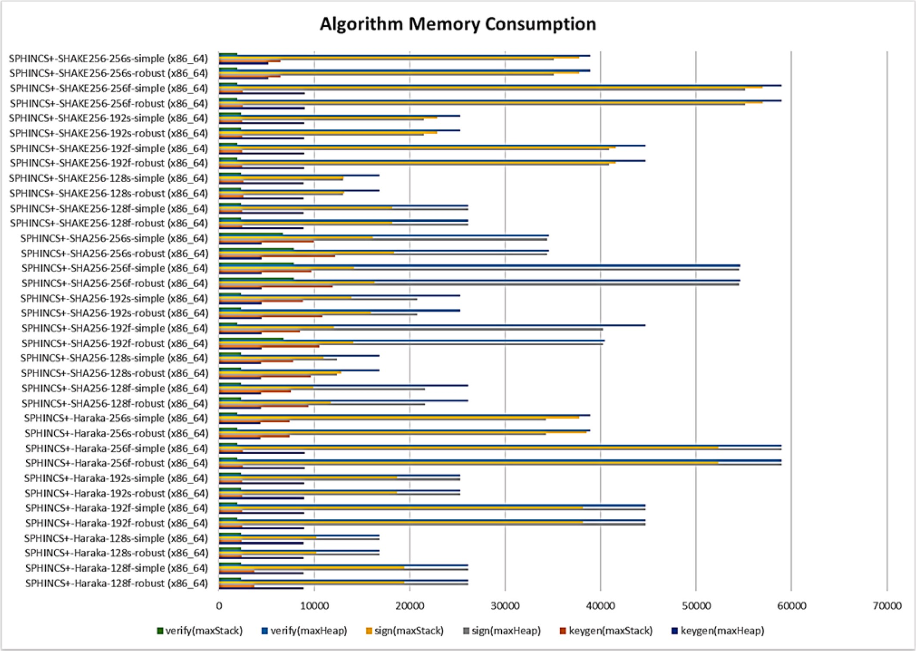

**Fig. 19.** Memory consumption (bytes per algorithm) (Digital Signature using Hash-Based Algorithms).

**Table 11**

Isogeny-based quantum-safe cryptographic algorithms.

Sl. No. Algorithm Name Current Status Open-Source C Library for Quantum-Safe Cryptographic Algorithms (liboqs) Usage

|  |  |  |  |  |  |  |  |
| --- | --- | --- | --- | --- | --- | --- | --- |
|  | | | NIST Level | Algorithms Name | Public Key Size (bytes) | Private Key Size (bytes) |  |
| 1 | SIKE | Alternates | 1 | SIDH-p434 | 330 | 28 | Key Encapsulation Mechanisms |
|  |  |  |  | SIDH-p434-compressed | 197 | 28 |  |
|  |  |  |  | SIKE-p434 | 330 | 374 |  |
|  |  |  |  | SIKE-p434-compressed | 197 | 350 |  |
|  |  |  | 2 | SIDH-p503 | 378 | 32 |  |
|  |  |  |  | SIDH-p503-compressed | 225 | 32 |  |
|  |  |  |  | SIKE-p503 | 378 | 434 |  |
|  |  |  |  | SIKE-p503-compressed | 225 | 407 |  |
|  |  |  | 3 | SIDH-p610 | 462 | 39 |  |
|  |  |  |  | SIDH-p610-compressed | 274 | 39 |  |
|  |  |  |  | SIKE-p610 | 462 | 524 |  |
|  |  |  |  | SIKE-p610-compressed | 274 | 491 |  |
|  |  |  | 5 | SIDH-p75 | 564 | 48 |  |
|  |  |  |  | SIDH-p751-compressed | 335 | 48 |  |
|  |  |  |  | SIKE-p751 | 564 | 644 |  |
|  |  |  |  | SIKE-p751-compressed | 335 | 602 |  |

However, the detailed performance analysis for GeMSS is available on GeMSS official website [44].

* 1. *Hash-based cryptography*

Cryptographic hash functions are non-reversible function that takes a string of any length as input and produces a fixed-length output. Hash- based cryptography is popularly used for digital signatures such as

Merkle signature. It combines a one-time signature with the Merkle tree. The hash-based signature (HBS) is a collection of many one-time signature (OTS) schemes. HBS uses a tree data structure to combine many OTS in an efficient manner. To sign a message, an HBS chooses a single OTS from its collection and uses it to sign the message [29]. The critical issue is that the HBS must never choose the same OTS twice, or else security is compromised. Hash-based quantum-safe cryptographic algorithms are:

**Table 12**

Runtime analysis of open quantum safe isogeny based cryptographic algorithms (Key encapsulation mechanisms).

|  |  |  |  |  |  |  |  |
| --- | --- | --- | --- | --- | --- | --- | --- |
| Algorithm | Keygen/s | Keygen | Encaps/s | Encaps | Decaps/s | Decaps |  |
|  |  | (cycles) |  | (cycles) |  | (cycles) |
| SIDH-p434 (x86_64) | 109.63 | 22805106 | 53.61 | 46626958 | 135.2 | 18488925 |  |
| SIDH-p434-compressed (x86_64) | 57.09 | 43,797,293 | 38.69 | 64616727 | 119.7 | 20885902 |  |
| SIDH-p503 (x86_64) | 318.89 | 7840371 | 155.4 | 16,085,706 | 391.2 | 6389639 |  |
| SIDH-p503-compressed (x86_64) | 166.44 | 15020665 | 111.7 | 22385569 | 330.9 | 7,555,453 |  |
| SIDH-p610 (x86_64) | 30.91 | 80887652 | 15.93 | 156909224 | 37.1 | 67391175 |  |
| SIDH-p610-compressed (x86_64) | 18.88 | 132,403,975 | 13.28 | 188156935 | 36.07 | 69302679 |  |
| SIDH-p751 (x86_64) | 104.79 | 23,858,838 | 50.17 | 49,829,353 | 127.4 | 19629441 |  |
| SIDH-p751-compressed (x86_64) | 55.93 | 44696733 | 36.57 | 68372097 | 114.3 | 21,873,987 |  |
| SIKE-p434 (x86_64) | 98.8 | 25300016 | 60.57 | 41,275,416 | 56.52 | 44237605 |  |
| SIKE-p434-compressed (x86_64) | 57.71 | 43322569 | 36.58 | 68330870 | 52.79 | 47,358,432 |  |
| SIKE-p503 (x86_64) | 271.82 | 9197872 | 175 | 14283364 | 163 | 15,339,004 |  |
| SIKE-p503-compressed (x86_64) | 165.89 | 15,070,206 | 112.1 | 22309024 | 154.3 | 16200750 |  |
| SIKE-p610 (x86_64) | 30.84 | 81071205 | 16.84 | 148,430,862 | 16.75 | 149271935 |  |
| SIKE-p610-compressed (x86_64) | 18.99 | 131620069 | 13.28 | 188252832 | 16.99 | 147,137,618 |  |
| SIKE-p751 (x86_64) | 92.91 | 26906560 | 57.49 | 43,480,834 | 53.45 | 46777582 |  |
| SIKE-p751-compressed (x86_64) | 55.8 | 44,799,410 | 36.53 | 68,434,047 | 47.73 | 52,377,374 |  |

**Table 13**

Memory Use Analysis (bytes per algorithm) of Open Quantum Safe Isogeny Based Cryptographic Algorithms (Key Encapsulation Mechanisms).

|  |  |  |  |  |  |  |  |  |  |  |  |  |
| --- | --- | --- | --- | --- | --- | --- | --- | --- | --- | --- | --- | --- |
| Algorithm | Keygen |  | Keygen |  | Encaps |  | Encaps |  | Decaps |  | Decaps |  |
|  | (maxHeap) |  | (maxStack) |  | (maxHeap) |  | (maxStack) |  | (maxHeap) |  | (maxStack) |
| SIDH-p434 (x86_64) | 4534 |  | 9928 |  | 5002 |  | 10,376 |  | 5084 |  | 9576 |  |
| SIDH-p434-compressed (x86_64) | 4401 |  | 78,248 |  | 4736 |  | 57,624 |  | 4818 |  | 9576 |  |
| SIDH-p503 (x86_64) | 9234 |  | 2192 |  | 9738 |  | 2320 |  | 9864 |  | 2320 |  |
| SIDH-p503-compressed (x86_64) | 4433 |  | 92,456 |  | 4816 |  | 63,840 |  | 9558 |  | 2304 |  |
| SIDH-p610 (x86_64) | 4677 |  | 14,520 |  | 5332 |  | 15,112 |  | 5447 |  | 14,008 |  |
| SIDH-p610-compressed (x86_64) | 4489 |  | 146,840 |  | 4956 |  | 104,072 |  | 5071 |  | 15,352 |  |
| SIDH-p751 (x86_64) | 4788 |  | 11,416 |  | 5588 |  | 12,216 |  | 5728 |  | 10,440 |  |
| SIDH-p751-compressed (x86_64) | 4559 |  | 196,440 |  | 5130 |  | 123,944 |  | 5270 |  | 10,760 |  |
| SIKE-p434 (x86_64) | 4880 |  | 10,152 |  | 5242 |  | 10,504 |  | 5258 |  | 11,192 |  |
| SIKE-p434-compressed (x86_64) | 4723 |  | 78,248 |  | 4975 |  | 58,072 |  | 4991 |  | 15,912 |  |
| SIKE-p503 (x86_64) | 9636 |  | 2192 |  | 10,062 |  | 2832 |  | 5438 |  | 7768 |  |
| SIKE-p503-compressed (x86_64) | 4808 |  | 92,456 |  | 5112 |  | 64,368 |  | 5136 |  | 13,784 |  |
| SIKE-p610 (x86_64) | 5162 |  | 14,856 |  | 5672 |  | 15,320 |  | 5696 |  | 16,248 |  |
| SIKE-p610-compressed (x86_64) | 4941 |  | 146,840 |  | 5301 |  | 104,712 |  | 5325 |  | 25,144 |  |
| SIKE-p751 (x86_64) | 5384 |  | 12,200 |  | 6012 |  | 12,376 |  | 6044 |  | 12,792 |  |
| SIKE-p751-compressed (x86_64) | 5113 |  | 196,456 |  | 5555 |  | 124,696 |  | 5587 |  | 22,440 |  |

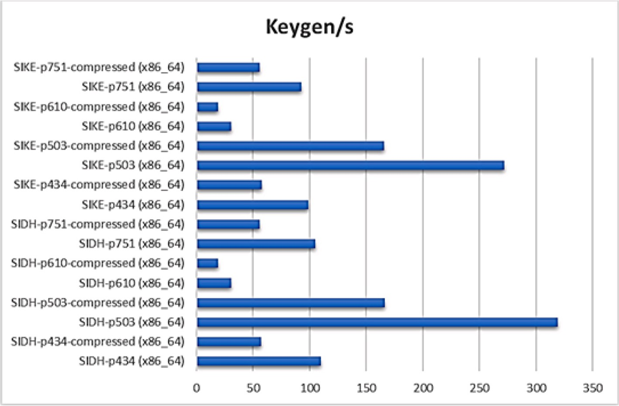

**Fig. 20.** Keygen operations per second per algorithm (Key Encapsulation Mechanisms using Isogeny Based Algorithms).

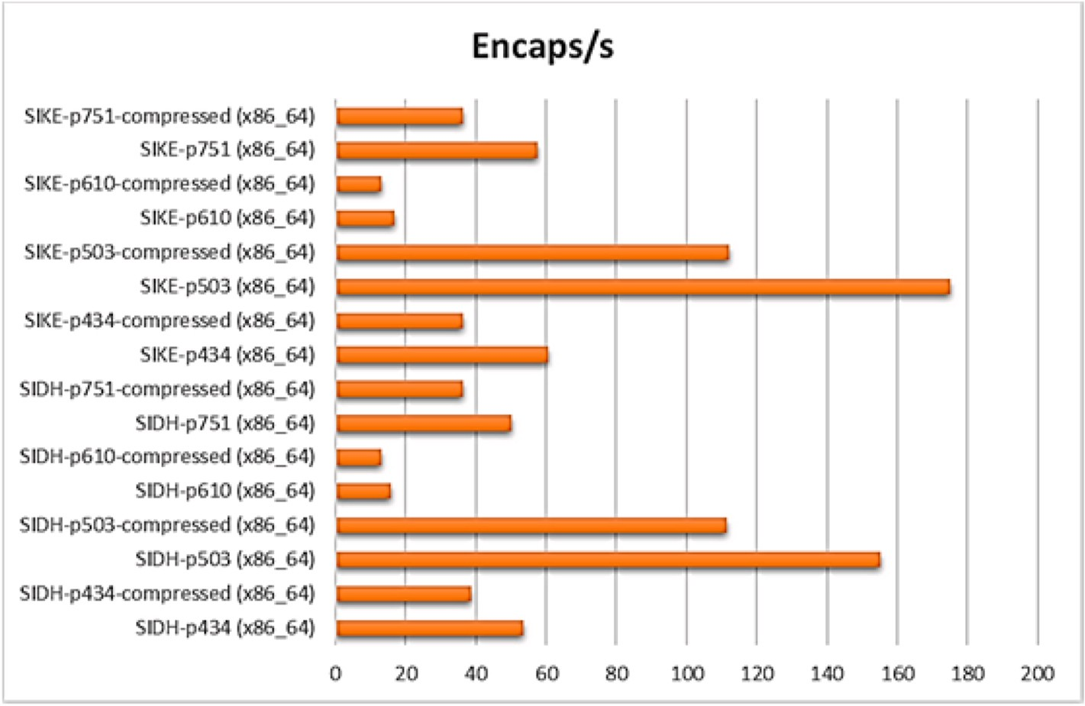

**Fig. 21.** Encaps operations per second per algorithm (Key Encapsulation Mechanisms using Isogeny Based Algorithms).

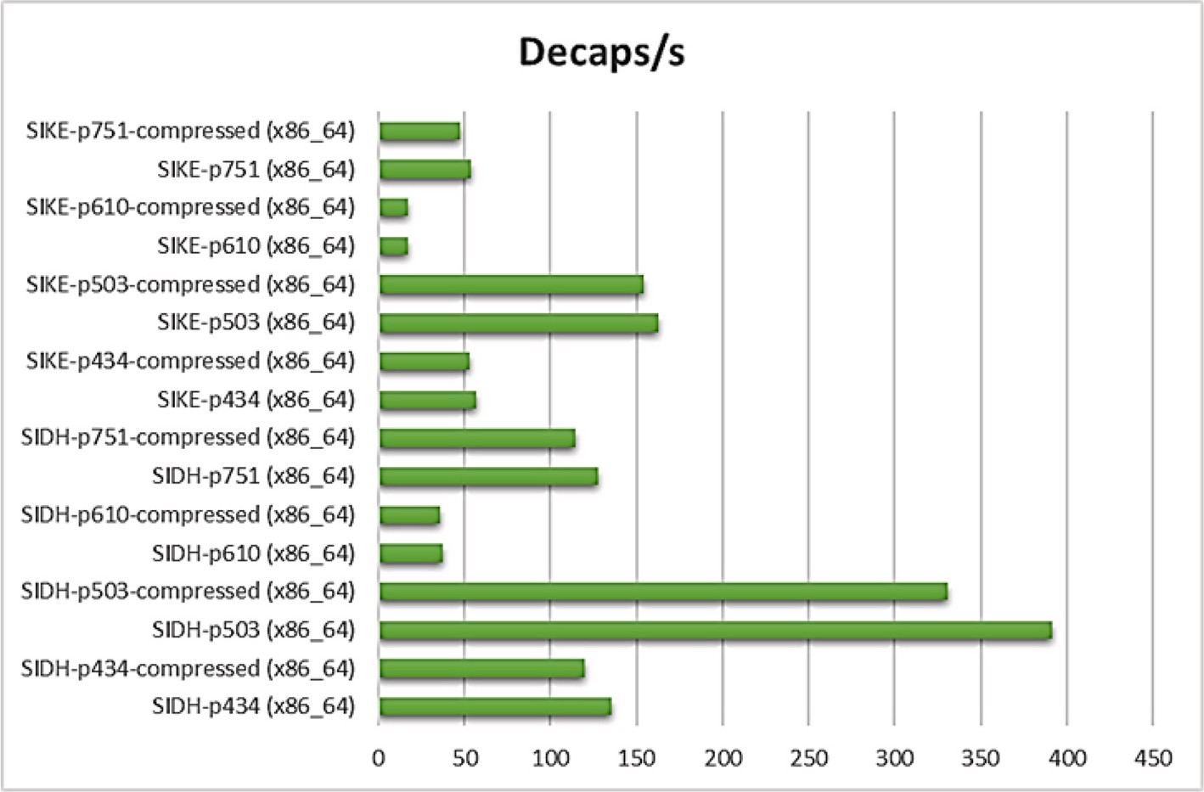

**Fig. 22.** Decaps operations per second per algorithm (Key Encapsulation Mechanisms using Isogeny Based Algorithms).

i) **SPHINCS**+ is a stateless hash-based signature scheme. It is an improvised version of SPHINCS, especially aimed to reduce the signature size [80]. The NIST submission of SPHINCS+ proposes three different signature schemes:

SPHINCS+-SHAKE256 SPHINCS+-SHA-256

SPHINCS+-Haraka

SPHINCS+ is announced as an alternate by NIST in the 3rd round of algorithm selection (Table 8). The algorithm can be used for digital signatures and can satisfy the NIST 1, 3, and 5 security levels. Runtime behavior and memory consumptions of SPHINCA+ are shown in Table 9, Table 10, and graphically represented in Fig. 16, Fig. 17,

Fig. 18, and Fig. 19.

* 1. *Isogeny based cryptography*

It is a relatively new technique that has begun in the year 2000. Isogeny-based cryptography uses maps between elliptic curves to build public-key cryptosystems. The security of Isogeny cryptography is based on so-called supersingular isogeny problems or in other words finding the isogeny mapping between two supersingular elliptic curves with the same number of points. The Isogeny-based protocols require a very small key compared to any other post-quantum cryptography candidates. SIKE is the one potential quantum-safe algorithm belonging to Isogeny cryptography family [30,40,82].

i) **SIKE** (Supersingular Isogeny Key Encapsulation) is an isogeny-based key encapsulation algorithm. The algorithm implementation is based on pseudo-random walks in supersingular isogeny graphs. SIKE has

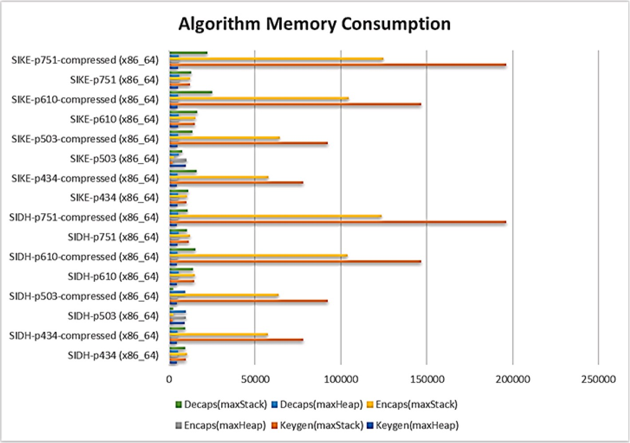

**Fig. 23.** Memory consumption (bytes per algorithm) (Key Encapsulation Mechanisms using Isogeny Based Algorithms).

**Table 14**

Lattice-based quantum-safe cryptographic algorithms.

Sl. No. Algorithm Name Current Open-Source C Library for Quantum-Safe Cryptographic Algorithms (liboqs) Usage

|  |  |  |  |  |  |  |  |
| --- | --- | --- | --- | --- | --- | --- | --- |
|  | | Status | NIST  Level | Algorithms Name | Public Key Size (bytes) | Private Key Size (bytes) |  |
| 1 | CRYSTALS-KYBER | Finalists | 1 | Kyber512 | 800 | 1632 | Key Encapsulation |
|  |  |  |  | Kyber512-90s | 800 | 1632 | Mechanisms |
|  |  |  | 3 | Kyber768 | 1184 | 2400 |  |
|  |  |  |  | Kyber768-90s | 1184 | 2400 |  |
|  |  |  | 5 | Kyber1024 | 1568 | 3168 |  |
|  |  |  |  | Kyber1024-90s | 1568 | 3168 |  |
| 2 | NTRU | Finalists | 1 | NTRU-HPS-2048-509 | 699 | 935 | Key Encapsulation |
|  |  |  | 3 | NTRU-HPS-2048-677 | 930 | 1234 | Mechanisms |
|  |  |  |  | NTRU-HRSS-701 | 1138 | 1450 |  |
|  |  |  | 5 | NTRU-HPS-4096-821 | 1230 | 1590 |  |
| 3 | SABER | Finalists | 1 | LightSaber-KEM | 672 | 1568 | Key Encapsulation |
|  |  |  | 3 | Saber-KEM | 992 | 2304 | Mechanisms |
|  |  |  | 5 | FireSaber-KEM | 1312 | 3040 |  |
| 4 | FrodoKEM | Alternates | 1 | FrodoKEM-640-AES | 9616 | 19,888 | Key Encapsulation |
|  |  |  |  | FrodoKEM-640-SHAKE | 9616 | 19,888 | Mechanisms |
|  |  |  | 3 | FrodoKEM-976-AES | 15,632 | 31,296 |  |
|  |  |  |  | FrodoKEM-976-SHAKE | 15,632 | 31,296 |  |
|  |  |  | 5 | FrodoKEM-1344-AES | 21,520 | 43,088 |  |
|  |  |  |  | FrodoKEM-1344- | 21,520 | 43,088 |  |
|  |  |  |  | SHAKE |  |  |  |
| 5 | NTRU Prime | Alternate | 1 | ntrulpr653 | 897 | 1125 | Key Encapsulation |
|  |  |  |  | sntrup653 | 994 | 1518 | Mechanisms |
|  |  |  | 2 | ntrulpr761 | 1039 | 1294 |  |
|  |  |  |  | sntrup761 | 1158 | 1763 |  |
|  |  |  | 3 | ntrulpr857 | 1184 | 1463 |  |
|  |  |  |  | sntrup857 | 1322 | 1999 |  |
| 6 | CRYSTALS- | Finalists | 2 | Dilithium2 | 1312 | 2528 | Digital Signature Algorithms |
|  | DILITHIUM |  |  | Dilithium2-AES | 1312 | 2528 |  |
|  |  |  | 3 | Dilithium3 | 1952 | 4000 |  |
|  |  |  |  | Dilithium3-AES | 1952 | 4000 |  |
|  |  |  | 5 | Dilithium5 | 2592 | 4864 |  |
|  |  |  |  | Dilithium5-AES | 2592 | 4864 |  |
| 7 | FALCON | Finalists | 1 | Falcon-512 | 897 | 1281 | Digital Signature Algorithms |
|  |  |  | 5 | Falcon-1024 | 1793 | 2305 |  |

the smallest public key size but it is also one of the slowest algorithms [10,76,78].

SIKE is the only one algorithm based on Isogney, which could make a

place in the NIST 3rd round (Table 11). However, it is declared as an alternate candidate, not the finalist. The runtime behavior and memory consumptions of the algorithm are shown in Table 12, Table 13, and graphically represented in Fig. 20, Fig. 21, Fig. 22, and Fig. 23.

Runtime analysis of open quantum safe lattice-based cryptographic algorithms (Key encapsulation mechanisms).

|  |  |  |  |  |  |  |  |
| --- | --- | --- | --- | --- | --- | --- | --- |
| Algorithm | Keygen/s | Keygen | Encaps/s | Encaps | Decaps/s | Decaps |  |
|  |  | (cycles) |  | (cycles) |  | (cycles) |
| FireSaber-KEM (x86_64) | 21419.7 | 116,577 | 20332.3 | 122,807 | 21,608 | 115,601 |  |
| FrodoKEM-1344-AES (x86_64) | 589 | 4,244,465 | 463.18 | 5,397,844 | 475.17 | 5,261,594 |  |
| FrodoKEM-1344-SHAKE (x86_64) | 200.07 | 12,494,691 | 192.33 | 12,999,407 | 192.87 | 12962247 |  |
| FrodoKEM-640-AES (x86_64) | 2179 | 1147030 | 1578 | 1584240 | 1653 | 1512386 |  |
| FrodoKEM-640-SHAKE (x86_64) | 794 | 3,148,801 | 669.11 | 3735711 | 719.76 | 3473037 |  |
| FrodoKEM-976-AES (x86_64) | 1041.32 | 2400233 | 783.74 | 3189368 | 816 | 3,063,901 |  |
| FrodoKEM-976-SHAKE (x86_64) | 371.42 | 6,731,021 | 340.22 | 7348775 | 341.66 | 7316407 |  |
| Kyber1024 (x86_64) | 35,936 | 69,446 | 31185.3 | 80,016 | 41011.33 | 60,859 |  |
| Kyber1024-90s (x86_64) | 51866.3 | 48,061 | 45,639 | 54,625 | 67,317 | 37,038 |  |
| Kyber512 (x86_64) | 67,526 | 36,882 | 58398.7 | 42,674 | 92577.67 | 26,910 |  |
| Kyber512-90s (x86_64) | 86,699 | 28,696 | 81124.7 | 30,692 | 135048.3 | 18,406 |  |
| Kyber768 (x86_64) | 46470.7 | 53,657 | 42638.7 | 58,493 | 59629.33 | 41,825 |  |
| Kyber768-90s (x86_64) | 66,675 | 37,353 | 60583.7 | 41,115 | 96815.67 | 25,724 |  |
| LightSaber-KEM (x86_64) | 44989.7 | 55,426 | 46,295 | 53,860 | 53519.67 | 46,617 |  |
| NTRU-HPS-2048-509 (x86_64) | 14,699 | 169,936 | 60072.3 | 41,464 | 71687.33 | 34,780 |  |
| NTRU-HPS-2048-677 (x86_64) | 8829 | 283,020 | 46316.7 | 53,816 | 48695.67 | 51,245 |  |
| NTRU-HPS-4096-821 (x86_64) | 6555.67 | 381,217 | 39904.7 | 62,494 | 38197.33 | 65,355 |  |
| NTRU-HRSS-701 (x86_64) | 9552.67 | 261,573 | 66261.7 | 37,568 | 46262.67 | 53,946 |  |
| Saber-KEM (x86_64) | 29017.7 | 86,015 | 29338.3 | 85,067 | 32,348 | 77,189 |  |
| ntrulpr653 (x86_64) | 32654.3 | 76,422 | 29,245 | 85,325 | 27985.67 | 89,232 |  |
| ntrulpr761 (x86_64) | 31496.3 | 79,234 | 30106.7 | 82,886 | 27409.33 | 91,111 |  |
| ntrulpr857 (x86_64) | 26,871 | 92,888 | 24131.7 | 103,440 | 20983.33 | 119,045 |  |
| sntrup653 (x86_64) | 2980.33 | 838,768 | 37,728 | 66,108 | 37468.33 | 66,618 |  |
| sntrup761 (x86_64) | 2349.33 | 1064025 | 34414.7 | 72,484 | 37,841 | 65,973 |  |
| sntrup857 (x86_64) | 1814.33 | 1377979 | 29393.7 | 84,894 | 28335.67 | 88,127 |  |

**Table 16**

Memory Use Analysis (bytes per algorithm) of Open Quantum Safe Lattice-Based Cryptographic Algorithms (Key Encapsulation Mechanisms).

|  |  |  |  |  |  |  |  |  |  |  |  |  |
| --- | --- | --- | --- | --- | --- | --- | --- | --- | --- | --- | --- | --- |
| Algorithm | Keygen |  | Keygen |  | Encaps |  | Encaps |  | Decaps |  | Decaps |  |
|  | (maxHeap) |  | (maxStack) |  | (maxHeap) |  | (maxStack) |  | (maxHeap) |  | (maxStack) |
| FireSaber-KEM (x86_64) | 8752 |  | 25,744 |  | 10,256 |  | 25,904 |  | 10,288 |  | 27,408 |  |
| FrodoKEM-1344-AES (x86_64) | 68,832 |  | 88,512 |  | 90,448 |  | 173,352 |  | 90,480 |  | 216,616 |  |
| FrodoKEM-1344-SHAKE (x86_64) | 69,616 |  | 77,352 |  | 91,280 |  | 123,720 |  | 90,480 |  | 165,704 |  |
| FrodoKEM-640-AES (x86_64) | 34,160 |  | 43,392 |  | 43,464 |  | 84,008 |  | 43,480 |  | 104,616 |  |
| FrodoKEM-640-SHAKE (x86_64) | 34,512 |  | 37,896 |  | 44,248 |  | 58,624 |  | 44,264 |  | 79,264 |  |
| FrodoKEM-976-AES (x86_64) | 51,152 |  | 64,616 |  | 67,088 |  | 128,064 |  | 67,376 |  | 159,488 |  |
| FrodoKEM-976-SHAKE (x86_64) | 51,936 |  | 55,712 |  | 67,704 |  | 89,568 |  | 67,728 |  | 121,024 |  |
| Kyber1024 (x86_64) | 13,560 |  | 16,720 |  | 11,344 |  | 21,944 |  | 11,376 |  | 23,544 |  |
| Kyber1024-90s (x86_64) | 13,560 |  | 17,168 |  | 10,512 |  | 19,928 |  | 10,544 |  | 21,528 |  |
| Kyber512 (x86_64) | 11,256 |  | 7504 |  | 8240 |  | 11,704 |  | 8272 |  | 12,504 |  |
| Kyber512-90s (x86_64) | 11,256 |  | 7952 |  | 7408 |  | 9720 |  | 7440 |  | 10,520 |  |
| Kyber768 (x86_64) | 12,408 |  | 11,600 |  | 9712 |  | 16,344 |  | 9744 |  | 17,464 |  |
| Kyber768-90s (x86_64) | 12,408 |  | 11,984 |  | 8880 |  | 14,264 |  | 8912 |  | 15,384 |  |
| LightSaber-KEM (x86_64) | 6416 |  | 14,776 |  | 7184 |  | 14,936 |  | 7216 |  | 15,704 |  |
| NTRU-HPS-2048-509 (x86_64) | 5810 |  | 35,744 |  | 6541 |  | 30,816 |  | 6573 |  | 29,120 |  |
| NTRU-HPS-2048-677 (x86_64) | 6340 |  | 50,944 |  | 7302 |  | 44,160 |  | 7334 |  | 41,888 |  |
| NTRU-HPS-4096-821 (x86_64) | 6996 |  | 64,320 |  | 8258 |  | 56,288 |  | 8290 |  | 53,632 |  |
| NTRU-HRSS-701 (x86_64) | 6764 |  | 49,136 |  | 7934 |  | 42,352 |  | 7966 |  | 42,128 |  |
| Saber-KEM (x86_64) | 7472 |  | 19,928 |  | 8592 |  | 20,088 |  | 8624 |  | 21,208 |  |
| ntrulpr653 (x86_64) | 6198 |  | 26,328 |  | 7255 |  | 26,552 |  | 7287 |  | 27,864 |  |
| ntrulpr761 (x86_64) | 6509 |  | 27,512 |  | 7708 |  | 27,672 |  | 7740 |  | 29,208 |  |
| ntrulpr857 (x86_64) | 6823 |  | 34,968 |  | 8167 |  | 35,064 |  | 8199 |  | 36,760 |  |
| sntrup653 (x86_64) | 6688 |  | 23,064 |  | 7617 |  | 24,120 |  | 7649 |  | 24,152 |  |
| sntrup761 (x86_64) | 7097 |  | 23,672 |  | 8168 |  | 24,888 |  | 8200 |  | 24,984 |  |
| sntrup857 (x86_64) | 7497 |  | 30,616 |  | 8713 |  | 31,960 |  | 8745 |  | 32,056 |  |

* 1. *Lattice-based cryptography*

Lattice-based cryptography is based on the computational hardness of lattice problems, the basis of which is the shortest vector problem (SVP). Here, we are given an input, lattice represented by an arbitrary basis, and our goal is to output the shortest nonzero vector in it [42,59, 67]. Simply put, the goal of the attacker is to find the shortest vector

from the origin when given the basis of a lattice. A zero vector doesn’t work as an answer. The space requirement of this algorithm is expo- nential and the best-known algorithm has a running time of 2*O*(*n* log *n*) for an exact solution to SVP or even just an approximation to within poly(n)

factors. Lattice-based cryptography provides a promising solution for post-quantum cryptography [60,64]. The algorithm is relatively effi- cient in implementation and has very strong security proofs based on worst-case hardness. The potential quantum-safe algorithm based on the lattice is as follows:

* + 1. **CRYSTALS-KYBER** encompasses two cryptographic primitives: [Kyber](https://pq-crystals.org/kyber/index.shtml), an IND-CCA2-secure key-encapsulation mechanism (KEM); and [Dilithium](https://pq-crystals.org/dilithium/index.shtml), a strongly EUF-CMA-secure digital signa- ture algorithm. Both the algorithms are based on the hard prob- lem using lattice. The algorithm is computationally fast and has a

**Table 17**

Runtime analysis of open quantum safe lattice-based cryptographic algorithms (digital signature algorithms).

|  |  |  |  |  |  |  |  |
| --- | --- | --- | --- | --- | --- | --- | --- |
| Algorithm | Keypair/s | Keypair | Sign/s | Sign | Verify/s | Verify |  |
|  |  | (cycles) |  | (cycles) |  | (cycles) |
| Dilithium2 (x86_64) | 26417.7 | 94,494 | 10,520 | 237479 | 29,132 | 85721 |  |
| Dilithium2-AES (x86_64) | 44800 | 55671 | 14407.7 | 173,353 | 44537.33 | 56039 |  |
| Dilithium3 (x86_64) | 16110.3 | 155032 | 6506.33 | 384098 | 17561.33 | 142,256 |  |
| Dilithium3-AES (x86_64) | 29631 | 84225 | 9637.67 | 259239 | 30018.33 | 83,182 |  |
| Dilithium5 (x86_64) | 10141.7 | 246360 | 5279.67 | 473377 | 10341 | 241,650 |  |
| Dilithium5-AES (x86_64) | 19582 | 127496 | 8141.33 | 306924 | 19511.33 | 128,032 |  |
| Falcon-1024 (x86_64) | 40.23 | 62157513 | 1446.52 | 1727907 | 9782.67 | 255449 |  |
| Falcon-512 (x86_64) | 105.05 | 23,797,285 | 2890.33 | 864862 | 19684.33 | 126886 |  |

**Table 18**

Memory Use Analysis (bytes per algorithm) of Open Quantum Safe Lattice-Based Cryptographic Algorithms (Digital Signature Algorithms).

|  |  |  |  |  |  |  |  |  |  |  |  |  |
| --- | --- | --- | --- | --- | --- | --- | --- | --- | --- | --- | --- | --- |
| Algorithm | Keygen |  | Keygen |  | Sign |  | Sign |  | Verify |  | Verify |  |
|  | (maxHeap) |  | (maxStack) |  | (maxHeap) |  | (maxStack) |  | (maxHeap) |  | (maxStack) |
| Dilithium2 (x86_64) | 12656 |  | 20,880 |  | 11,584 |  | 49,616 |  | 11360 |  | 21592 |  |
| Dilithium2-AES (x86_64) | 12,656 |  | 17,040 |  | 15,400 |  | 44,816 |  | 10,528 |  | 14,800 |  |
| Dilithium3 (x86_64) | 14,768 |  | 25,656 |  | 14,569 |  | 78,808 |  | 14,345 |  | 24,728 |  |
| Dilithium3-AES (x86_64) | 14,768 |  | 20,792 |  | 18,385 |  | 69,424 |  | 13,513 |  | 16,848 |  |
| Dilithium5 (x86_64) | 16,272 |  | 33,848 |  | 17,375 |  | 113,232 |  | 17,151 |  | 31,128 |  |
| Dilithium5-AES (x86_64) | 16,272 |  | 26,936 |  | 21,191 |  | 108,336 |  | 16,319 |  | 21,264 |  |
| Falcon-1024 (x86_64) | 12,914 |  | 36,792 |  | 14,344 |  | 80,880 |  | 9696 |  | 10,512 |  |
| Falcon-512 (x86_64) | 10,994 |  | 19,216 |  | 11,784 |  | 40,944 |  | 11,784 |  | 2320 |  |

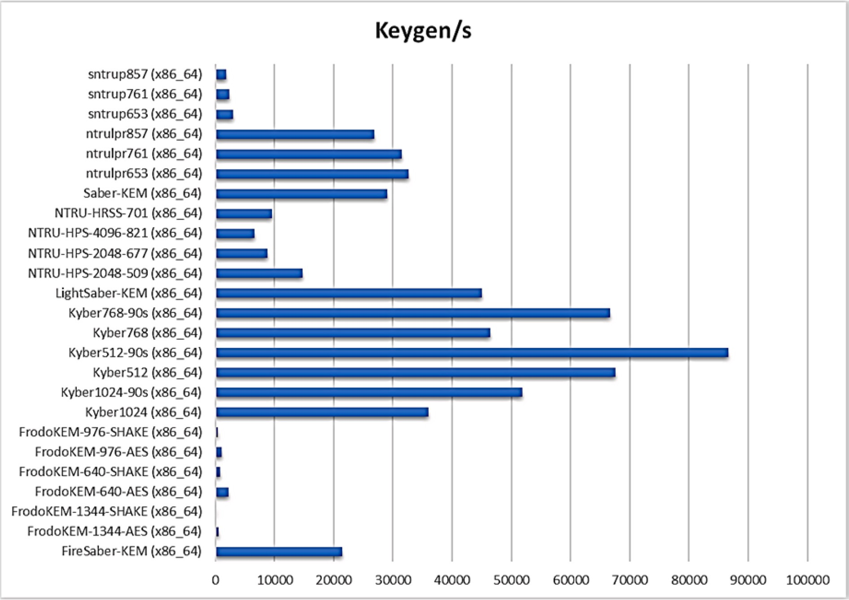

**Fig. 24.** Keygen operations per second per algorithm (Key Encapsulation Mechanisms using Lattice Based Algorithms).

small public key [32]. It has different parameters set to match the NIST security levels 1, 3, and 5.

* + 1. **NTRU** is lattice-based cryptography. It was developed in 1996 by mathematicians Jeffrey Hoffstein, Jill Pipher, and Joseph H.

Silverman. In 2013, Damien Stehle and Ron Steinfeld developed a post-quantum secure version of NTRU. It is based on the hardness of solving the Ring-learning-with-errors problem (Ring-LWE).

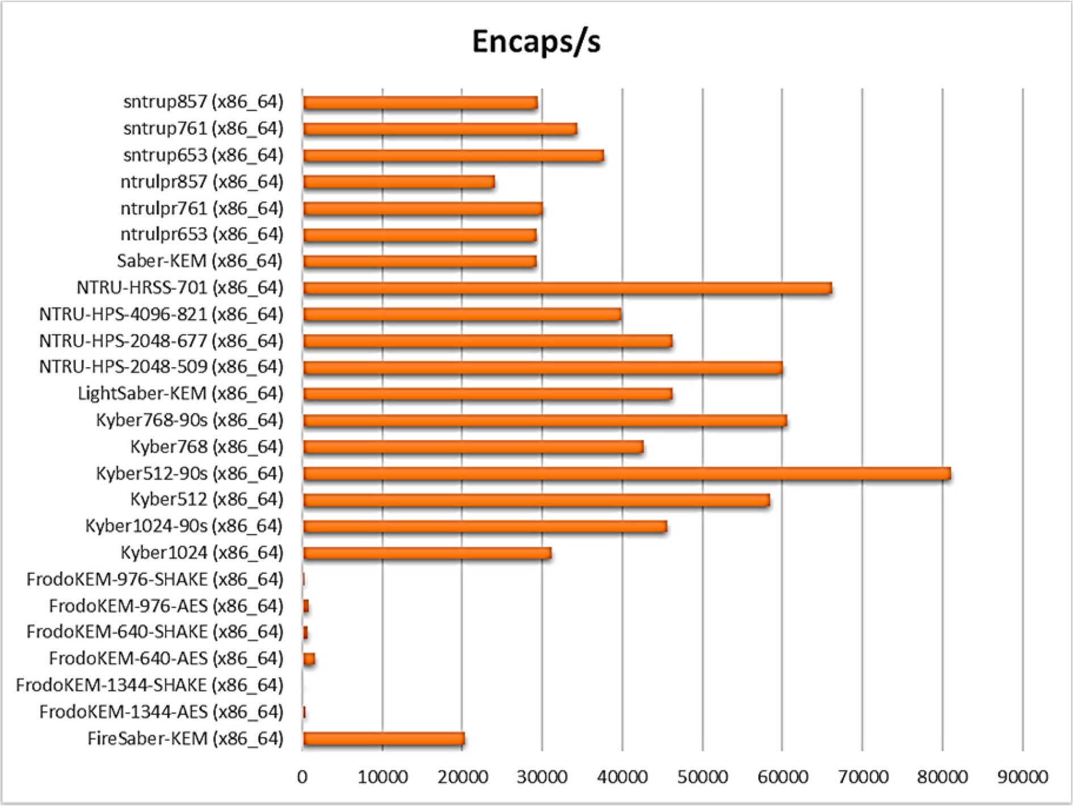

**Fig. 25.** Encaps operations per second per algorithm (Key Encapsulation Mechanisms using Lattice Based Algorithms).

The algorithm is resistant to attacks using Shor’s algorithm [59, 89].

* + 1. **SABER** also belongs to the lattice-based cryptography algorithm family. The security of the algorithm relies on the hardness of the Module Learning with Rounding problem (MLWR). SABER is a simple and efficient algorithm [34,74]. The SABER-suite offers three security levels:

LightSABER (NIST Level 1) SABER (NIST Level 3)

FireSABER (NIST Level 5)

* + 1. **FrodoKEM** is based on the algebraically unstructured lattice. The algorithm has fewer parameter restrictions but a large public key size [43]. FrodoKEM is designed for IND-CCA security at three levels:

FrodoKEM-640, which targets Level 1 in the NIST FrodoKEM-976, which targets Level 3 in the NIST FrodoKEM-1344, which targets Level 5 in the NIST

* + 1. **NTRU Prime** is an improvised version of the original NTRU which has eliminated many of the complications of the lattice security review [69].
    2. **CRYSTALS-DILITHIUM i**s based on the “Fiat-Shamir with Aborts” technique of Lyubashevsky which uses rejection sam- pling to make lattice-based Fiat-Shamir schemes compact and

secure [36,38]. Dilithium claims to have the smallest public key and signature size of any lattice-based signature scheme that only uses uniform sampling.

* + 1. **FALCON** is a lattice-based signature scheme designed on the theoretical framework of Gentry, Peikert, and Vaikuntanathan. The security of the algorithm is based on the underlying hard problem of the [short integer solution](https://en.wikipedia.org/wiki/Short_integer_solution_problem) problem (SIS) over NTRU

lattices, for which no efficient solving algorithm is currently known in the general case, even with the help of quantum com- puters [39].

Lattice-based cryptography algorithms seem to be the most prom- ising and quantum-safe. The maximum number of algorithms announced by NIST in 3rd round belongs to the lattice-based cryptog- raphy family (Table 14). There are three algorithms’ CRYSTALS-KYBER,

NTRU and SABER declared as a finalist for Key Encapsulation Mecha-

nisms [54]. CRYSTALS-DILITHIUM and FALCON are declared as a finalist for digital signatures. FrodoKEM and NTRU Prime have been announced as alternate candidates for Key Encapsulation Mechanisms. The runtime behavior and memory consumptions of the algorithms are shown in Table 15, Table 16, Table 17, and Table 18. The data from Table 15 to Table 18 has been graphically represented in Figs. 24–31.

# Implementation feasibility and migration challenges

Performance analysis of various quantum-safe algorithms shows that in general, quantum-safe algorithms require many CPU cycles for basic operations (i.e., key generation, encrypt/decrypt, key exchange, sign, verify, etc.). The algorithms also require large to a very large public key and private key sizes. The runtime memory consumption of these al- gorithms is very high compared to the classical cryptographic algorithms.

The higher CPU cycle and memory usage is constrained to the ICT systems and devices. The resource constraints can be resolved for the systems like a laptop, desktop, or high-end server up to some extent. However, it is a challenging issue for small devices like smartphones, sensor networks, smart-grid, IoT, smart devices, smart homes, etc.

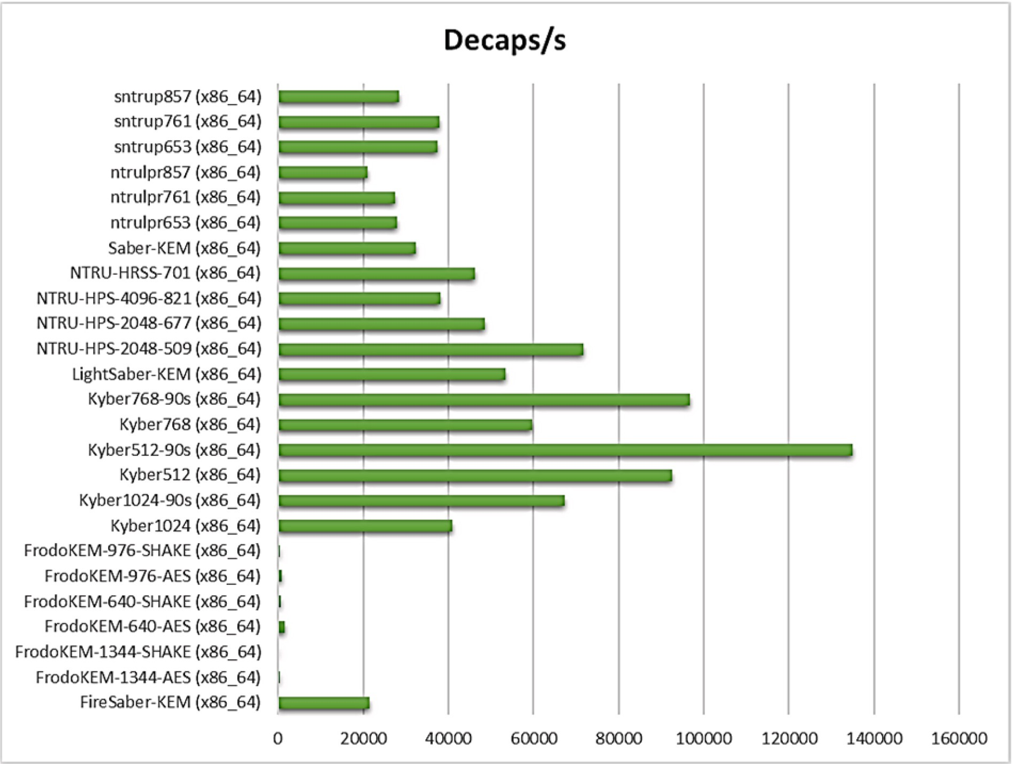

**Fig. 26.** Decaps operations per second per algorithm (Key Encapsulation Mechanisms using Lattice Based Algorithms).

Security is paramount for all types of ICT devices. Hence the implementation feasibility of quantum-safe algorithms is very impor- tant. NIST completed the 3rd round of the process for PQC Standardi- zation in July 2022. Considering various performance and feasibility factors, NIST has selected only four algorithms for standardization (Table 19). Additional four algorithms have been considered for advancement and 4th round of evaluation. The selected algorithm under consideration for the advancement and further evaluation in the 4th round needs to be upgraded on various performance factors to satisfy the implementation feasibility.

Adoption and implementation of these algorithms will depend on various factors such as throughput, latency threshold, key size limita- tions of current hardware and software, etc. The replacement of classical cryptography algorithms with quantum-safe algorithms will require changes in existing protocol, communication devices, and hardware with high processing capacity to accelerate the algorithm performance, application code, operating system, etc.

NIST is still in the process of finalizing Quantum-Safe algorithms. Most likely the process will continue to the fourth round of evaluation. The algorithms which are declared as a finalist has acceptable perfor- mance but require additional analysis to gain sufficient confidence. Some of the algorithms which are declared as alternate may potentially be standardized based on the high confidence in their security.

Currently, the prime objective is to develop a quantum-resistant al- gorithm to protect from a possible future attack. However, major implementation feasibility issues which require intense effort to over- come are:

**Migration Overhead and Complexity:** Migration to PQC will require significant upgradation in any organization’s current

•

cryptographic infrastructure. Some of their current IT components may become completely obsolete and will require replacement. The existing algorithms, software, and protocol may require redesign and changes. Overall, the entire migration process will add substantial budget overhead to the organization and unavoidable complexity.

* **Scalability Issue:** Scalability is a challenging issue for most of the

potential PQC algorithms. It is difficult to prove the hardness of the algorithm at scale. For example, lattice-based cryptography which is one of the popular techniques used for designing quantum-safe al- gorithms does manage to scale well but achieves average-case hardness. There is a trade-off between hardness and scalability. Either can be achieved, but not both.

* **Large Key Size and Speed:** Most of the potential PQC algorithms

require large to very large key sizes compared to the existing cryp- tography algorithms. Because of the large key size and complex al- gorithm, more time is required to encrypt, decrypt or verify the message at either end. It also requires more storage space in the device and a longer time to establish secure communication.

* **Resource-Constrained Devices:** Smartphones, IoT Devices, Sensor

Networks, Industrial Control Systems, and SCADA are some of the most critical components of our infrastructure. In general, these devices have less memory and processing capacity which poses a challenge for strong security implementation. Post-quantum cryp- tography algorithms require intense customization and feasibility study for their implementation in the resource-constrained device. It is tough to maintain the hardness of the cryptography algorithm while satisfying the resource constraints.

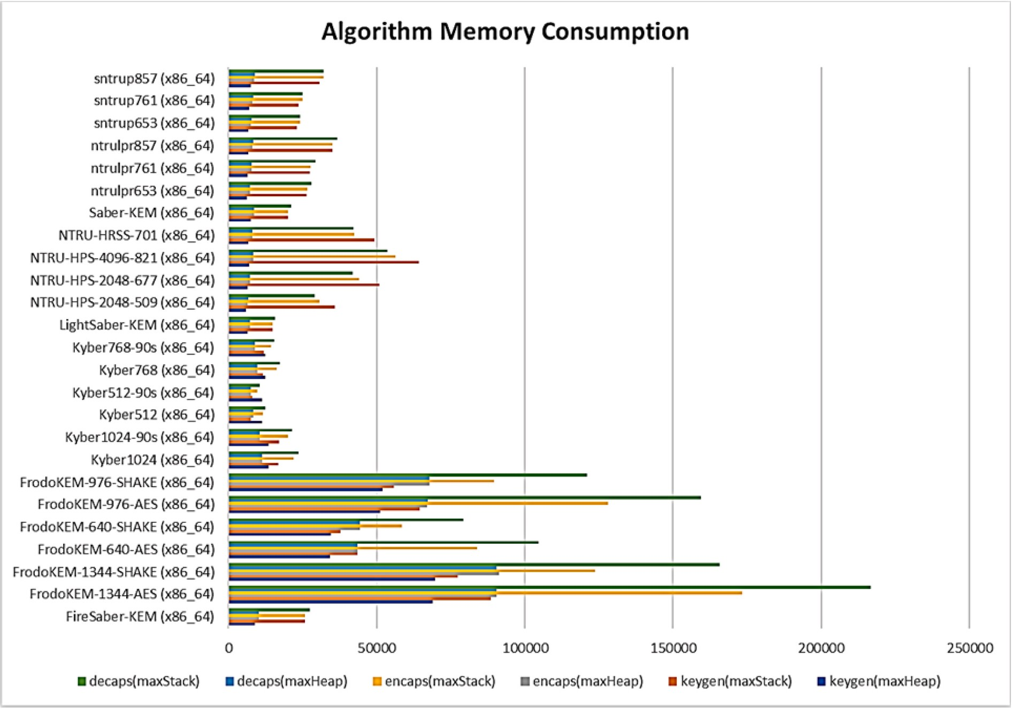

**Fig. 27.** Memory consumption (bytes per algorithm) (Key Encapsulation Mechanisms using Lattice Based Algorithms).

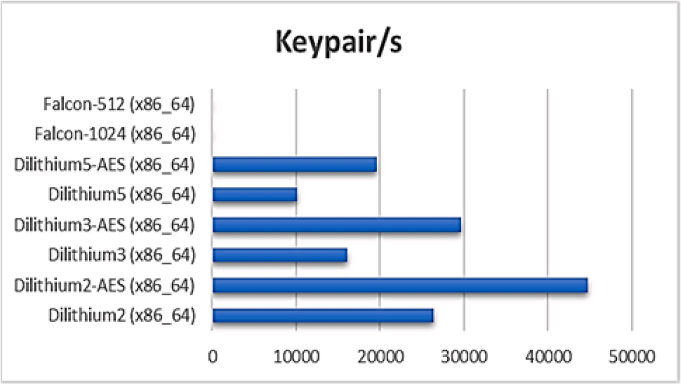

**Fig. 28.** Keypair operations per second per algorithm (Digital Signature using Lattice Based Algorithms).

# Conclusions

To break the current cryptographic algorithms, a quantum computer with millions of ‘Qubits’ is required. It is not sure when quantum com- puters with a scale of a million qubit will be available in the common-

place. However, the exponential growth in quantum computer technology’s development shows that the storm is approaching very fast. The information we communicate today is mostly encrypted using a

public-key cryptography algorithm that is vulnerable to quantum com- puters. It is quite possible that many hackers, state-sponsored or nation-

states themselves might be intercepting and harvesting the encrypted messages with envisioning that they will be able to decrypt these mes- sages when the quantum computing resources will be available in the future. To counter this threat, we need to migrate to post-quantum cryptographic algorithms at the earliest. Migration to post-quantum cryptographic algorithms requires thorough planning and implementa- tion globally. The migration process will require work on the various front including education, training, and awareness. It will require extensive coordination among many stakeholders involved in the design and development of hardware, software, and IT infrastructure

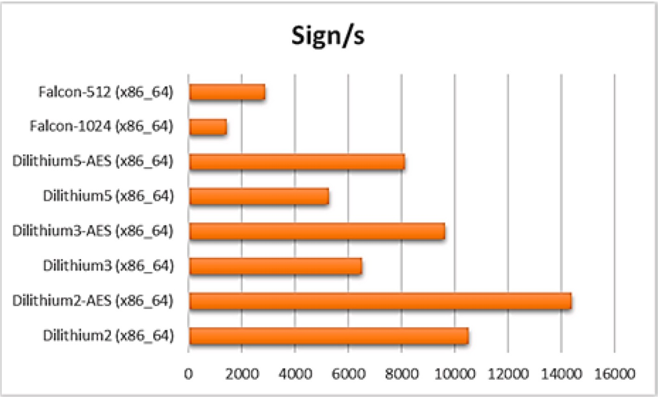

**Fig. 29.** Sign operations per second per algorithm (Digital Signature using Lattice Based Algorithms).

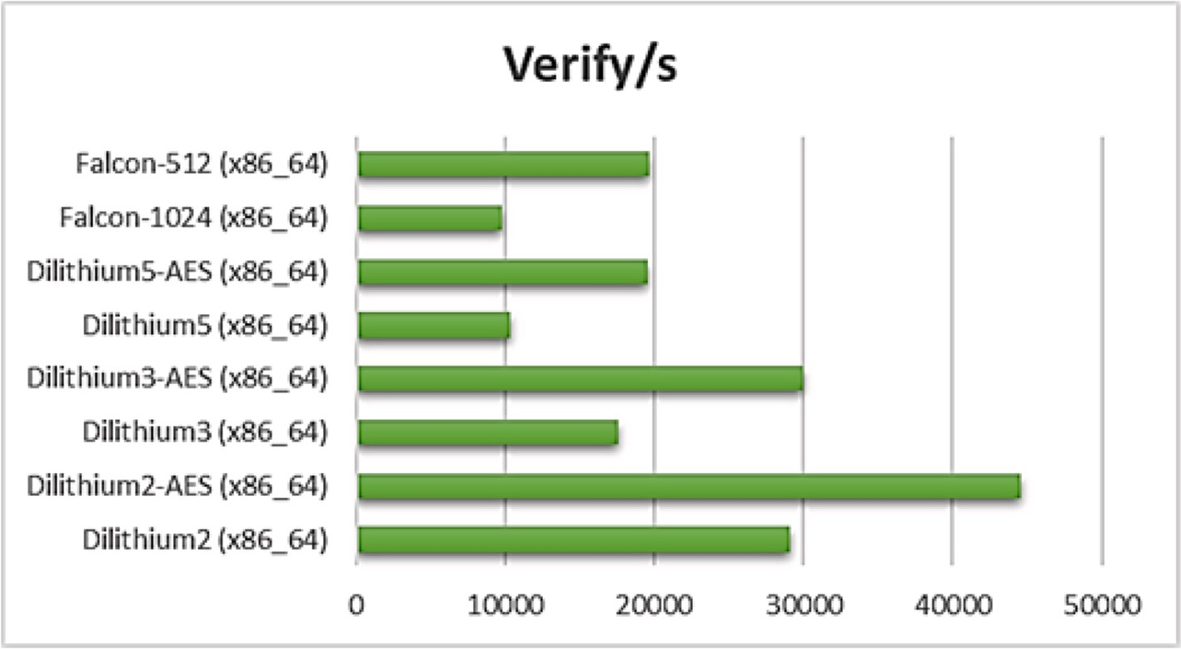

**Fig. 30.** Verify operations per second per algorithm (Digital Signature using Lattice Based Algorithms).

components. Early preparation will ensure a less costly and effective changeover with minimal disruption.

# Funding

Not applicable.

# Availability of data and material (data transparency)

Data sharing is not applicable to this article as no new data were created or analyzed in this study.

# Code availability

Not applicable.

# Ethics approval

Not applicable.

# Consent to participate

Not applicable.

# Consent for publication

Not applicable.

# Compliance with ethical standards

This article does not contain any studies with human participants or animals performed by any of the authors.

# Credit author statement

Manish Kumar Conceptualization; Methodology / Study design; Software; Validation; Formal analysis; Investigation; Resources; Data curation; Writing – original draft; Writing – review & editing; Visuali-

zation; Supervision; Project administration; Funding acquisition.

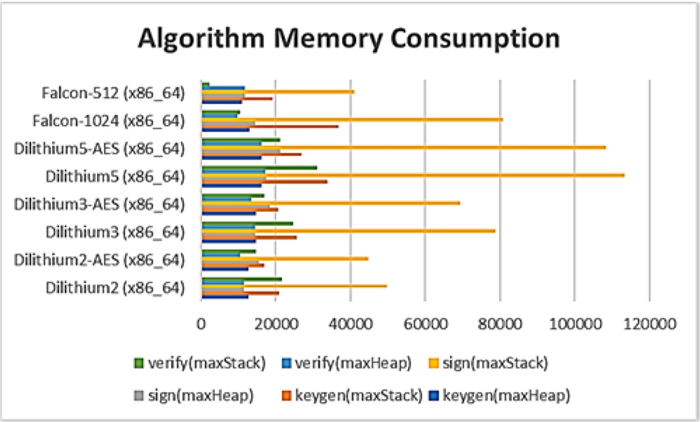

**Fig. 31.** Memory consumption (bytes per algorithm) (Digital Signature using Lattice Based Algorithms).

**Table 19**

List of Algorithms selected by NIST for standardization and 4th Round Consideration [3,6].

Algorithms Name

Design Security Performance Overall Assessment

**KEM Selected for Standardization**

**CRYSTALS-**

**Kyber**

Initially, it was IND- CPA-secure PKE scheme, then boosted to an IND-CCA-secure KEM

Strong theoretical security foundation based on lattice cryptography

The performance of KYBER in many different environments is satisfactory

Overall performance of KYBER in software, hardware, and hybrid settings are excellent.

**KEMs Advancing to the 4th Round BIKE** Based on binary linear

quasi-cyclic moderate density parity check (QC-MDPC) codes

Depends on the difficulty of solving the decisional Quasi-cyclic Syndrome Decoding (QCSD) and the decisional Quasi-cyclic Codeword Finding (QCCF) problems

The performance of BIKE would be suitable for most of the applications as confirmed by several hardware benchmarks

Because of the overall performance of the BIKE, it remains under consideration

**Classic McEliece**

Code Based KEM (Uses Binary Goppa Code)

Based on the hardness of decoding random codes as well as distinguishing scrambled Goppa codes from random codes.

It has the smallest ciphertext among any of the NIST PQC candidates

NIST is confident about the security of Classic McEliece. Hence it is still under consideration

**HQC** Based on QC-MDPC codes and follows an LWE-like encryption protocol

The security relies on the difficulty of the Quasi-cyclic Syndrome Decoding(QCSD) with parity problem

Bandwidth of the HQC exceeds that of BIKE, HQC’s key generation but decapsulation only requires a fraction of the kilocycles required

by BIKE. HQC is one of the top two alternate KEMs.

The overall performance of the HQC is not optimal but still, it is acceptable.

**SIKE** Based on isogenies The security of SIKE follows from the

hardness of finding isogenies between supersingular elliptic curves.

**Signatures Selected for Standardization**

It has relatively low communication costs. However, performance on embedded devices may be an issue because the time to perform a single key encapsulation/decapsulation.

It is relatively new scheme. It seems promising but needs further study.

**CRYSTALS-**

**Dilithium**

Lattice-based digital signature algorithm based on the Fiat- Shamir paradigm

The security is based on decisional Module Learning With Errors (MLWE) assumption, which suffices to show that the public key does not leak any information about the secret key.

It uses pseudorandomness and truncated storage techniques improve the performance. The scheme does not use floating-point arithmetic, which is an advantage.

Highly efficient and relatively simple in implementation.

**Falcon** Lattice-based signature scheme utilizing the

“hash-and-sign”

paradigm

**SPHINCS**+ Stateless hash-based

signature scheme

The theoretical security is based on the proof of unforgeability in the QROM, based on the hardness of the SIS Problem over NTRU lattices

The security of the SPHINCS+ relies on

the security of the underlying hash functions used

The verification process is fast and requires low bandwidth. It is the best choice for some constrained protocol scenarios.

Key generation and verification is much faster than signing

NIST has confidence in its security. Because of its low bandwidth, it is a preferred choice for certain applications.

It is selected for standardization because it provides a workable signature scheme whose security seems quite solid and is based on an entirely different set of assumptions than those of our other signature schemes to be standardized.

# Declaration of competing interest

The authors declare that they have no known competing financial interests or personal relationships that could have appeared to influence the work reported in this paper.

# References

1. A public-key cryptosystem based on algebraic coding theory. JPL Deep Space Network Progress 1978:114–6. Report 42– 44, [1978DSNPR..44..114M](http://1978DSNPR.44.114M/). Bibcode.
2. Alagic G, Alperin-Sheriff J, Apon D, Cooper D, Dang Q, Kelsey J, Liu Y-K, Miller C,

Moody D, Peralta R, Perlner R, Robinson A, Smith-Tone D. Status report on the second round of the NIST post-quantum cryptography standardization process. Gaithersburg, MD): National Institute of Standards and Technology; 2020. [https://](https://doi.org/10.6028/NIST.IR.8309) [doi.org/10.6028/NIST.IR.8309](https://doi.org/10.6028/NIST.IR.8309). NIST Internal Report (NISTIR) 8309.

1. Alagic G, Apon D, Cooper D, Dang Q, Dang T, Kelsey J, Lichtinger J, Miller C, Moody D, Peralta R, Perlne R, Robinson A, Smith-Tone D, Liu Y-K. Status report on the third round of the NIST post-quantum cryptography standardization process. NIST Publications; 2022. <https://doi.org/10.6028/nist.ir.8413>.
2. Algorithms. Open Quantum Safe, [openquantumsafe.org/liboqs/algorithms](http://openquantumsafe.org/liboqs/algorithms). Accessed 11 June 2021..
3. Althobaiti, Saud Ohood, Dohler Mischa. Cybersecurity challenges associated with the internet of Things in a post-quantum world. IEEE Access 2020;8:157356–81. <https://doi.org/10.1109/access.2020.3019345>.
4. Announcing PQC candidates to be standardized, Plus fourth round candidates | CSRC. 2022, July 5. Retrieved, [https://Csrc.Nist.Gov/](http://Csrc.Nist.Gov/). [Accessed 6 July 2022]. [htt](https://csrc.nist.gov/News/2022/pqc-candidates-to-be-standardized-and-round-4) [ps://csrc.nist.gov/News/2022/pqc-candidates-to-be-standardized-and-round-4](https://csrc.nist.gov/News/2022/pqc-candidates-to-be-standardized-and-round-4). from.
5. Arute Frank, et al. Quantum supremacy using a Programmable Superconducting processor. Nature 2019;574(7779):505–10. [https://doi.org/10.1038/s41586-019-](https://doi.org/10.1038/s41586-019-1666-5) [1666-5](https://doi.org/10.1038/s41586-019-1666-5).
6. arXiv. Emerging technology from the. How a Quantum Computer Could Break 2048-Bit RSA Encryption in 8 Hours 2 Apr. 2020. MIT Technology Review, [www.](http://www.technologyreview.com/2019/05/30/65724/how-a-quantum-computer-could-break-2048-bit-rsa-encryption-in-8-hours) [technologyreview.com/2019/05/30/65724/how-a-quantum-computer-could-b](http://www.technologyreview.com/2019/05/30/65724/how-a-quantum-computer-could-break-2048-bit-rsa-encryption-in-8-hours) [reak-2048-bit-rsa-encryption-in-8-hours](http://www.technologyreview.com/2019/05/30/65724/how-a-quantum-computer-could-break-2048-bit-rsa-encryption-in-8-hours).
7. Asif Rameez. Post-quantum cryptosystems for internet-of-Things: a Survey on lattice-based algorithms. IoT 2021;2(1):71–91. [https://doi.org/10.3390/](https://doi.org/10.3390/iot2010005) [iot2010005](https://doi.org/10.3390/iot2010005).
8. Azarderakhsh Reza. NIST Announces round 3 candidates, SIKE remains – PQSecure technologies. Pqsecurity; 27 July 2020. [www.pqsecurity.com/nist-announces-ro](http://www.pqsecurity.com/nist-announces-round-3-candidates-sike-remains)

[und-3-candidates-sike-remains](http://www.pqsecurity.com/nist-announces-round-3-candidates-sike-remains).

1. Azarderakhsh Reza. WP Release 2/12/2020 – PQSecure Technologies.” PQSecure Technologies 14 Feb. 2020. [www.pqsecurity.com/white-paper-release-2-12-2020](http://www.pqsecurity.com/white-paper-release-2-12-2020).
2. Balamurugan C, Singh K, Ganesan G, Rajarajan M. Post-quantum and code-based cryptography—some prospective research directions. Cryptography 2021;5(4):38. <https://doi.org/10.3390/cryptography5040038>.
3. Balamurugan Chithralekha, et al. Code-based post-quantum cryptography. 2021. <https://doi.org/10.20944/preprints202104.0734.v1>. Preprints.
4. Baldi Marco, et al. Post-quantum cryptography based on codes: state of the art and open challenges. 2017 AEIT International Annual Conference 2017. [https://doi.](https://doi.org/10.23919/aeit.2017.8240549) [org/10.23919/aeit.2017.8240549](https://doi.org/10.23919/aeit.2017.8240549).
5. Banerjee Utsav, et al. Accelerating post-quantum cryptography using an Energy- efficient TLS Crypto-Processor. 2020 IEEE International Symposium on Circuits and Systems (ISCAS) 2020. <https://doi.org/10.1109/iscas45731.2020.9180550>.
6. Barker William, et al. Getting ready for post-quantum cryptography: Exploring challenges associated with adopting and using post-quantum cryptographic algorithms. NIST Cybersecurity White Paper 2021. [https://doi.org/10.6028/nist.](https://doi.org/10.6028/nist.cswp.04282021) [cswp.04282021](https://doi.org/10.6028/nist.cswp.04282021).
7. Bernstein, D. J., Chuengsatiansup, C., Lange, T., & Vredendaal, C. (n.d.). NTRU Prime. <https://ntruprime.cr.yp.to/>. Retrieved April 21, 2021, from [https://ntrupr](https://ntruprime.cr.yp.to/ntruprime-20160511.pdf) [ime.cr.yp.to/ntruprime-20160511.pdf](https://ntruprime.cr.yp.to/ntruprime-20160511.pdf).
8. Bernstein DJ, Hülsing A, Ko¨lbl S, Niederhagen R, Rijneveld J, Schwabe P. The

SPHINCS signature framework. In Proceedings of the 2019 ACM SIGSAC Conference on Computer and Communications Security (CCS ’19) 2019:2129–46. <https://doi.org/10.1145/3319535.3363229>.

+

1. Beullens W, D’Anvers J-P, Hülsing AT, Lange T, Panny L, de Saint Guilhem C, Smart NP. Post-Quantum Cryptography: current state and quantum mitigation. ENISA; 2021. <https://doi.org/10.2824/92307>.
2. Billet O, Gilbert H. Cryptanalysis of Rainbow. Lect Notes Comput Sci 2006:336–47. <https://doi.org/10.1007/11832072_23>.
3. Borges Fabio, et al. A Comparison of security and its performance for key Agreements in post-quantum cryptography. IEEE Access 2020;8:142413–22. <https://doi.org/10.1109/access.2020.3013250>. Crossref.
4. Bos J, Costello C, Ducas L, Mironov I, Naehrig M, Nikolaenko V, Raghunathan A, Stebila D. Frodo. Proceedings of the 2016 ACM SIGSAC conference on computer and communications security. 2016. <https://doi.org/10.1145/2976749.2978425>.
5. Broadbent Anne, Schaffner Christian. Quantum cryptography beyond quantum key Distribution. Des Codes Cryptogr 2015;78(1):351–82. [https://doi.org/10.1007/](https://doi.org/10.1007/s10623-015-0157-4) [s10623-015-0157-4](https://doi.org/10.1007/s10623-015-0157-4).
6. Buchanan William, Woodward Alan. Will quantum computers Be the end of public key encryption? Journal of Cyber Security Technology 2016;1(1):1–22. [https://](https://doi.org/10.1080/23742917.2016.1226650) [doi.org/10.1080/23742917.2016.1226650](https://doi.org/10.1080/23742917.2016.1226650).
7. Casanova A, Faug`ere JC, Macario-Rat G, Patarin J, Perret L, Ryckeghem J. GeMSS: a great multivariate Short signature. n.d. Retrieved, <https://www-polsys.lip6.fr/>.

[Accessed 6 August 2021]. [https://www-polsys.lip6.fr/Links/NIST/GeMSS_spec](https://www-polsys.lip6.fr/Links/NIST/GeMSS_specification.pdf) [ification.pdf](https://www-polsys.lip6.fr/Links/NIST/GeMSS_specification.pdf). from.

1. Chen L. Cryptography standards in quantum time: new wine in an Old Wineskin? IEEE Security & Privacy 2017;15(4):51–7. [https://doi.org/10.1109/](https://doi.org/10.1109/MSP.2017.3151339) [MSP.2017.3151339](https://doi.org/10.1109/MSP.2017.3151339).
2. Chen L, Jordan S, Liu Y-K, Moody D, Peralta R, Perlner R, Smith-Tone D (2016) Report on post-quantum cryptography*.* (National Institute of Standards and Technology, Gaithersburg, MD), NIST Internal Report (NISTIR) 8105. [https://doi.](https://doi.org/10.6028/NIST.IR.8105) [org/10.6028/NIST.IR.8105](https://doi.org/10.6028/NIST.IR.8105)..
3. Chen Jiajun. Review on quantum communication and quantum computation.

J Phys Conf 2021;1865(2):022008. [https://doi.org/10.1088/1742-6596/1865/2/](https://doi.org/10.1088/1742-6596/1865/2/022008) [022008](https://doi.org/10.1088/1742-6596/1865/2/022008). Crossref.

1. Corporation, Isara. “Math Paths to quantum-safe security: hash-based cryptography.” ISARA Corporation, [www.isara.com/blog-posts/hash-based-cr](http://www.isara.com/blog-posts/hash-based-cryptography.html) [yptography.html](http://www.isara.com/blog-posts/hash-based-cryptography.html). Accessed 2 Aug. 2021.
2. Costello Craig. Supersingular isogeny key exchange for Beginners. Lect Notes Comput Sci 2020:21–50. <https://doi.org/10.1007/978-3-030-38471-5_2>.
3. Cryptographic algorithm - Glossary | CSRC. (n.d.). [https://Csrc.Nist.Gov/Glossary](http://Csrc.Nist.Gov/Glossary/Term/Cryptographic_algorithm)

[/Term/Cryptographic_algorithm](http://Csrc.Nist.Gov/Glossary/Term/Cryptographic_algorithm). Retrieved April 5, 2022, from [https://csrc.nist.go](https://csrc.nist.gov/glossary/term/cryptographic_algorithm) [v/glossary/term/cryptographic_algorithm](https://csrc.nist.gov/glossary/term/cryptographic_algorithm).

1. CRYSTALS. *CRYSTALS*, pq-crystals.org. Accessed 5 Nov. 2021.
2. Bellizia D, et al. Post-quantum cryptography: challenges and Opportunities for Robust and secure HW design. In: 2021 IEEE International Symposium on Defect

and fault tolerance in VLSI and Nanotechnology systems (DFT); 2021. p. 1–6. <https://doi.org/10.1109/DFT52944.2021.9568301>.

1. D’Anvers J-P, Karmakar A, Sinha Roy S, Vercauteren F. Saber: Module-LWR based key exchange, CPA-secure encryption and CCA-secure KEM. 2019, March 18.

Retrieved, <https://eprint.iacr.org/>. [Accessed 8 May 2022]. [https://eprint.iacr.](https://eprint.iacr.org/2018/230.pdf) [org/2018/230.pdf](https://eprint.iacr.org/2018/230.pdf). from.

1. Diffie W, Hellman M. New directions in cryptography. IEEE Trans Inf Theor 1976; 22(6):644–54. <https://doi.org/10.1109/tit.1976.1055638>.
2. Dilithium.Dilithium, [pq-crystals.org/dilithium](http://pq-crystals.org/dilithium). Accessed 21 July 2021.
3. Don Jelle, et al. Security of the Fiat-Shamir Transformation in the quantum random-Oracle model. Advances in Cryptology – CRYPTO 2019 2019:356–83. <https://doi.org/10.1007/978-3-030-26951-7_13>.
4. Ducas, L., Kiltz, E., Lepoint, T., Lyubashevsky, V., Schwabe, P., Seiler, G., & Stehl´e,

D. (2018). CRYSTALS-dilithium: a lattice-based digital signature scheme. IACR Transactions on Cryptographic Hardware and Embedded Systems, 2018(1), 238–268. <https://doi.org/10.13154/tches.v2018.i1.238-268>.

1. Falcon. Falcon, [falcon-sign.info](http://falcon-sign.info/). Accessed 3 June 2021.
2. [Feo Luca De. Mathematics of isogeny based cryptography. 2017, 04062. *ArXiv* abs/](http://refhub.elsevier.com/S2590-0056(22)00077-7/sref40) [1711](http://refhub.elsevier.com/S2590-0056(22)00077-7/sref40).
3. Feynman Richard P. Simulating Physics with computers. Int J Theor Phys 1982;21 (6–7):467–88. <https://doi.org/10.1007/bf02650179>.
4. Fouque P-A, Hoffstein J, Kirchner P, Lyubashevsky V, Pornin T, Prest T, Ricosset T,

Seiler G, Whyte W, Zhang Z. n.d. Falcon: Fast-Fourier Lattice-based Compact Signatures over NTRU 2018. Retrieved, [https://www.di.ens.fr/](http://www.di.ens.fr/). [Accessed 26 March 2021]. [https://www.di.ens.fr/~prest/Publications/falcon.pdf](https://www.di.ens.fr/%7Eprest/Publications/falcon.pdf). from

1. FrodoKEM. FrodoKEM, [frodokem.org](http://frodokem.org/). Accessed 9 July 2021.
2. GeMSS: A great multivariate Short signature.” GeMSS: A Great Multivariate Short Signature, [www-polsys.lip6.fr/Links/NIST/GeMSS.html](http://www-polsys.lip6.fr/Links/NIST/GeMSS.html). Accessed 8 Oct. 2021.
3. [Gibney E. Quantum computer race intensifies as alternative technology gains](http://refhub.elsevier.com/S2590-0056(22)00077-7/sref45) [steam. Nature 2020;587(7834):342–3](http://refhub.elsevier.com/S2590-0056(22)00077-7/sref45).
4. Gisin Nicolas, et al. Quantum cryptography. Rev Mod Phys 2002;74(1):145–95. <https://doi.org/10.1103/revmodphys.74.145>. Crossref.
5. Global Risk Institute. A Methodology for Quantum Risk Assessment 8 Nov. 2017. Global Risk Institute, [globalriskinstitute.org/publications/3423-2](http://globalriskinstitute.org/publications/3423-2).
6. Global Risk Institute. Quantum Threat Timeline Report 2020 1 Feb. 2021. Global Risk Institute, [globalriskinstitute.org/publications/quantum-threat-timeline-report](http://globalriskinstitute.org/publications/quantum-threat-timeline-report-2020)

[-2020](http://globalriskinstitute.org/publications/quantum-threat-timeline-report-2020).

1. Grover Lov K. A fast quantum mechanical algorithm for database search. In: Proceedings of the Twenty-Eighth Annual ACM Symposium on theory of computing - STOC ’96; 1996. <https://doi.org/10.1145/237814.237866>.
2. Gupta DS, Ray S, Singh T, Kumari M. Post-quantum lightweight identity-based two-

party authenticated key exchange protocol for Internet of Vehicles with probable security. Comput Commun 2022;181:69–79. [https://doi.org/10.1016/j.](https://doi.org/10.1016/j.comcom.2021.09.031) [comcom.2021.09.031](https://doi.org/10.1016/j.comcom.2021.09.031).

1. Hamming quasi-cyclic (HQC) third round version. 2020, January 10. Retrieved, [https://pqc-hqc.org/](http://pqc-hqc.org/). [Accessed 11 May 2021]. [https://pqc-hqc.org/doc/hqc-spec](https://pqc-hqc.org/doc/hqc-specification_2020-10-01.pdf) [ification_2020-10-01.pdf](https://pqc-hqc.org/doc/hqc-specification_2020-10-01.pdf). from.
2. Help Net Security. Quantum computers: how to prepare for this great threat to information security. Published, [Helpnetsecurity.com](http://Helpnetsecurity.com/). [Accessed 24 April 2021]. <https://www.helpnetsecurity.com/2020/11/06/quantum-computers-threat/>.
3. IBM Quantum Composer. n.d. [https://Quantum-Computing.Ibm.Com/Comp](http://Quantum-Computing.Ibm.Com/Composer/Docs/Iqx/Guide/Shors-Algorithm) [oser/Docs/Iqx/Guide/Shors-Algorithm](http://Quantum-Computing.Ibm.Com/Composer/Docs/Iqx/Guide/Shors-Algorithm). [https://quantum-computing.ibm.com/](https://quantum-computing.ibm.com/composer/docs/iqx/guide/shors-algorithm) [composer/docs/iqx/guide/shors-algorithm](https://quantum-computing.ibm.com/composer/docs/iqx/guide/shors-algorithm).
4. Bos J, et al. Crystals - Kyber: A CCA-secure Module-lattice-based KEM. In: 2018 IEEE European Symposium on security and privacy (EuroS&P); 2018. p. 353–67. <https://doi.org/10.1109/EuroSP.2018.00032>.
5. Joseph D, Misoczki R, Manzano M, Tricot J, Pinuaga FD, Lacombe O, Leichenauer S, Hidary J, Venables P, Hansen R. Transitioning organizations to post-quantum cryptography. Nature 2022;605(7909):237–43. [https://doi.org/](https://doi.org/10.1038/s41586-022-04623-2)

[10.1038/s41586-022-04623-2](https://doi.org/10.1038/s41586-022-04623-2).

1. [Kazutoshi Kan, Masashi Une. Recent Trends on Research and Development of](http://refhub.elsevier.com/S2590-0056(22)00077-7/sref56) [Quantum Computers and Standardization of Post-Quantum Cryptography 2 Feb.](http://refhub.elsevier.com/S2590-0056(22)00077-7/sref56)

[2021. IMES Discussion Paper Series 21-E-05, Institute for Monetary and Economic](http://refhub.elsevier.com/S2590-0056(22)00077-7/sref56) [Studies, Bank of Japan](http://refhub.elsevier.com/S2590-0056(22)00077-7/sref56).

1. LaMacchia B. The long road ahead to transition to post-quantum cryptography. Commun ACM 2022;65(1):28–30. <https://doi.org/10.1145/3498706>.
2. Lee J, Kim W, Kim S, Kim JH. Post-quantum cryptography Coprocessor for RISC-V

CPU core. 2022 International Conference on Electronics, Information, and Communication (ICEIC) 2022:1–2. [https://doi.org/10.1109/](https://doi.org/10.1109/iceic54506.2022.9748834) [iceic54506.2022.9748834](https://doi.org/10.1109/iceic54506.2022.9748834).

1. Lei X, Liao X. NTRU-KE: a lattice-based public key exchange protocol. 2013, March

11. Retrieved, <https://eprint.iacr.org/>. [Accessed 12 April 2021]. from [https://](https://eprint.iacr.org/2013/718.pdf) [eprint.iacr.org/2013/718.pdf](https://eprint.iacr.org/2013/718.pdf).

1. Liu Zhe, et al. Securing Edge devices in the post-quantum internet of Things using lattice-based cryptography. IEEE Commun Mag 2018;56(2):158–62. [https://doi.](https://doi.org/10.1109/mcom.2018.1700330) [org/10.1109/mcom.2018.1700330](https://doi.org/10.1109/mcom.2018.1700330).
2. Kumar M, Pattnaik P. Post quantum cryptography(PQC) - an overview: (Invited

paper). 2020 IEEE High Performance Extreme Computing Conference (HPEC) 2020:1–9. <https://doi.org/10.1109/HPEC43674.2020.9286147>.

1. Malina, Lukas, et al. “Post-quantum Era privacy protection for Intelligent infrastructures.” IEEE Access, vol. 9, 2021, pp. 36038–36077. Crossref, doi: 10.1109/access.2021.3062201.
2. Malina Lukas, Popelova Lucie, et al. On feasibility of post-quantum cryptography on small devices. IFAC-PapersOnLine 2018;51(6):462–7. [https://doi.org/10.1016/](https://doi.org/10.1016/j.ifacol.2018.07.104) [j.ifacol.2018.07.104](https://doi.org/10.1016/j.ifacol.2018.07.104). Crossref.
3. Micciancio Daniele, Regev Oded. Lattice-based cryptography. Post-Quantum Cryptography 2009:147–91. <https://doi.org/10.1007/978-3-540-88702-7_5>. *Crossref*.
4. Mosca Michele. Cybersecurity in an Era with quantum computers: will We Be ready? IEEE Security & Privacy 2018;16(5):38–41. [https://doi.org/10.1109/](https://doi.org/10.1109/msp.2018.3761723) [msp.2018.3761723](https://doi.org/10.1109/msp.2018.3761723).
5. Sendrier N. Code-based cryptography: state of the art and perspectives. IEEE Security & Privacy 2017;15(4):44–50. [https://doi.org/10.1109/](https://doi.org/10.1109/MSP.2017.3151345) [MSP.2017.3151345](https://doi.org/10.1109/MSP.2017.3151345).
6. Nejatollahi Hamid, et al. Post-quantum lattice-based cryptography implementations. ACM Comput Surv 2019;51(6):1–41. [https://doi.org/10.1145/](https://doi.org/10.1145/3292548) [3292548](https://doi.org/10.1145/3292548).
7. [Nicolas Aragon, Barreto Paulo, Bettaieb Slim, Bidoux Loïc, Olivier Blazy, et al.](http://refhub.elsevier.com/S2590-0056(22)00077-7/sref68) [BIKE: bit flipping key encapsulation. 2017. ffhal-01671903f](http://refhub.elsevier.com/S2590-0056(22)00077-7/sref68).
8. NTRU prime: Intro.*NTRU prime: Intro*, ntruprime.cr.yp.to. Accessed 21 June 2021.
9. Overbeck R, Sendrier N. Code-based cryptography. In: Bernstein DJ, Buchmann J, Dahmen E, editors. Post-quantum cryptography. Berlin, Heidelberg: Springer; 2009. <https://doi.org/10.1007/978-3-540-88702-7_4>.
10. Ovilla-Martínez Brisbane, et al. FPGA implementation of some second round NIST lightweight cryptography candidates. Electronics 2020;9(11):1940. [https://doi.](https://doi.org/10.3390/electronics9111940) [org/10.3390/electronics9111940](https://doi.org/10.3390/electronics9111940).
11. Rainbow. Open Quantum Safe, [openquantumsafe.org/liboqs/algorithms/sig/rai](http://openquantumsafe.org/liboqs/algorithms/sig/rainbow.html) [nbow.html](http://openquantumsafe.org/liboqs/algorithms/sig/rainbow.html). Accessed 10 Sept. 2021.
12. Roma, Crystal Andrea, et al. “Energy efficiency analysis of post-quantum cryptographic algorithms.” IEEE Access, vol. 9, 2021, pp. 71295–71317. Crossref, doi:10.1109/access.2021.3077843.
13. SABER, Lwr-Based KEM. SABER: LWR-Based KEM. [www.esat.kuleuven.be/cosic](http://www.esat.kuleuven.be/cosic/pqcrypto/saber)

[/pqcrypto/saber](http://www.esat.kuleuven.be/cosic/pqcrypto/saber). [Accessed 21 August 2021].

1. Samuel GreengardCommissioned by CACM Staff. The Scramble for post-quantum cryptography.” news | communications of the ACM. 4 Feb. 2021. [cacm.acm.org/ne](http://cacm.acm.org/news/250331-the-scramble-for-post-quantum-cryptography/fulltext) [ws/250331-the-scramble-for-post-quantum-cryptography/fulltext](http://cacm.acm.org/news/250331-the-scramble-for-post-quantum-cryptography/fulltext).
2. [Seo H, Anastasova M, Jalali A, Azarderakhsh R. Supersingular isogeny key](http://refhub.elsevier.com/S2590-0056(22)00077-7/sref76) [encapsulation (SIKE) round 2 on ARM Cortex-M4. IEEE Trans Comput 2020;70](http://refhub.elsevier.com/S2590-0056(22)00077-7/sref76)

[(10):1705–18](http://refhub.elsevier.com/S2590-0056(22)00077-7/sref76).

1. Sevilla J. Assessing the impact of quantum cryptanalysis. 2020, July 22. [https://Docs.Google.Com/Document/d/1lFczb2-ACsm51rJt8ljH0eyNh](http://Docs.Google.Com/Document/d/1lFczb2-ACsm51rJt8ljH0eyNhWrRR0YZ1dlLOZP-Zos/Edit#heading%3Dh.Omwb9lyolrg2) [WrRR0YZ1dlLOZP-Zos/Edit#heading h.Omwb9lyolrg2](http://Docs.Google.Com/Document/d/1lFczb2-ACsm51rJt8ljH0eyNhWrRR0YZ1dlLOZP-Zos/Edit#heading%3Dh.Omwb9lyolrg2). [https://docs.google.](https://docs.google.com/document/d/1lFczb2-ACsm51rJt8ljH0eyNhWrRR0YZ1dlLOZP-zos/edit#heading%3Dh.omwb9lyolrg2) [com/document/d/1lFczb2-ACsm51rJt8ljH0eyNhWrRR0YZ1dlLOZP-zos/edit#h](https://docs.google.com/document/d/1lFczb2-ACsm51rJt8ljH0eyNhWrRR0YZ1dlLOZP-zos/edit#heading%3Dh.omwb9lyolrg2) [eading h.omwb9lyolrg2](https://docs.google.com/document/d/1lFczb2-ACsm51rJt8ljH0eyNhWrRR0YZ1dlLOZP-zos/edit#heading%3Dh.omwb9lyolrg2).

[=](http://Docs.Google.Com/Document/d/1lFczb2-ACsm51rJt8ljH0eyNhWrRR0YZ1dlLOZP-Zos/Edit#heading%3Dh.Omwb9lyolrg2)

[=](https://docs.google.com/document/d/1lFczb2-ACsm51rJt8ljH0eyNhWrRR0YZ1dlLOZP-zos/edit#heading%3Dh.omwb9lyolrg2)

1. SIKE – Supersingular Isogeny Key Encapsulation. SIKE – Supersingular Isogeny Key Encapsulation 2018. [sike.org](http://sike.org/). [Accessed 15 September 2021].
2. Singh H. Code based Cryptography: Classic McEliece 2019. [arXiv.Org](http://arXiv.Org/). [htt](https://arxiv.org/abs/1907.12754) [ps://arxiv.org/abs/1907.12754](https://arxiv.org/abs/1907.12754). July 302019.
3. SPHINCS . sphincs.org. Accessed 5 July 2021.

+

1. Strand M. A Status Update on quantum safe cryptography. 2021 International conference on military communication and information systems (ICMCIS). 2021. <https://doi.org/10.1109/icmcis52405.2021.9486413>.
2. Taraskin Oleg, Soukharev Vladimir, Jao David, LeGrow Jason T. Towards isogeny-

based Password-authenticated key establishment. J Math Cryptol 2021;15(1): 18–30. <https://doi.org/10.1515/jmc-2020-0071>.

1. Tmilinovic. Quantum computing timeline by Gartner. Tmilinovic’s Blog 18 Jan. 2019. [tmilinovic.wordpress.com/2019/01/18/quantum-computing-timeline-by-](http://tmilinovic.wordpress.com/2019/01/18/quantum-computing-timeline-by-gartner)

[gartner](http://tmilinovic.wordpress.com/2019/01/18/quantum-computing-timeline-by-gartner).

1. Verma Pramode. Unconditional security through quantum Uncertainty. International Journal of Critical Infrastructure Protection 2017;16:36–8. [https://](https://doi.org/10.1016/j.ijcip.2016.09.001) [doi.org/10.1016/j.ijcip.2016.09.001](https://doi.org/10.1016/j.ijcip.2016.09.001).
2. Wallden Petros, Kashefi Elham. Cyber security in the quantum Era. Communications of the ACM, 1 Apr. 2019 April 2019;62(4):120. [cacm.acm.org/ma](http://cacm.acm.org/magazines/2019/4/235578-cyber-security-in-the-quantum-era/fulltext) [gazines/2019/4/235578-cyber-security-in-the-quantum-era/fulltext](http://cacm.acm.org/magazines/2019/4/235578-cyber-security-in-the-quantum-era/fulltext).
3. Wallden Petros, Kashefi Elham. Cyber security in the quantum Era. Commun ACM 2019;62(4):120. <https://doi.org/10.1145/3241037>.
4. Wang J, Liu L, Lyu S, Wang Z, Zheng M, Lin F, Chen Z, Yin L, Wu X, Ling C. Quantum-safe cryptography: crossroads of coding theory and cryptography. Sci China Inf Sci 2021;65(1). <https://doi.org/10.1007/s11432-021-3354-7>.
5. Wang Liu-Jun, et al. Experimental authentication of quantum key Distribution with post-quantum cryptography. Npj Quantum Information 2021;7(1). [https://doi.](https://doi.org/10.1038/s41534-021-00400-7) [org/10.1038/s41534-021-00400-7](https://doi.org/10.1038/s41534-021-00400-7).
6. Zhang Jiang, et al. Tweaking the Asymmetry of asymmetric-key cryptography on lattices: KEMs and signatures of smaller sizes. Lect Notes Comput Sci 2020:37–65. <https://doi.org/10.1007/978-3-030-45388-6_2>.
7. Zhou Tianqi, et al. Quantum cryptography for the future internet and the security analysis. Secur Commun Network 2018;2018:1–7. [https://doi.org/10.1155/2018/](https://doi.org/10.1155/2018/8214619) [8214619](https://doi.org/10.1155/2018/8214619).

# Acronyms

***ANSI****:* The American National Standards Institute

***AWS****:* Amazon Web Service

***BIKE****:* Bit Flipping Key Encapsulation

***BSI****:* Federal Office for Information Security, Germany

***CFRG****:* Crypto Forum Research Group

***CPU****:* Central Processing Unit

***ECC****:* Elliptic Curve Cryptography

***ETSI****:* The European Telecommunications Standards Institute

***EUF-CMA****:* Existential Unforgeability Under Chosen Message Attack

***GeMSS****:* A Great Multivariate Short Signature

***HBS****:* Hash-Based Signature

***HFE****:* Hidden Field Equations Cryptosystem

***HQC****:* Hamming Quasi-Cyclic

***ICT****:* Information and Communications Technology

***IETF****:* The Internet Engineering Task Force

***IND-CCA****:* Indistinguishability Under Chosen Ciphertext Attack

***IND-CCA1****:* Indistinguishability Under (Non-Adaptive) Chosen Ciphertext Attack

***IND-CPA****:* Indistinguishability Under Chosen-Plaintext Attack

***KEM****:* Key Encryption Mechanisms

***MLWR****:* Module Learning with Rounding

***NIST****:* The National Institute of Standards and Technology ***NP-Complete****:* Non-Deterministic Polynomial-Time Complete ***NP-Hard****:* Non-Deterministic Polynomial-Time Hardness ***OQS****:* Open Quantum Safe

***OTS****:* One-Time Signature

***PKE****:* Public Key Encryption

***PQC****:* Post Quantum Cryptography

***QCCF****:* Quasi-cyclic Codeword Finding

***QC-MDPC****:* Quasi-Cyclic Moderate Density Parity-Check

***QCSD****:* Quasi-Cyclic Syndrome Decoding ***QROM****:* Quantum Random Oracle Model ***QSC****:* Quantum-Safe Cryptography

***RFC****:* Request for Comment

***Ring-LWE****:* The Ring-Learning-With-Errors ***SCADA****:* Supervisory Control and Data Acquisition ***SIKE****:* Supersingular Isogeny Key Encapsulation ***SIS****:* Short Integer Solution

***SSL/TLS****:* Secure Sockets Layer /Transport Layer Security

***SVP****:* Shortest Vector Problem

***XMSS****:* eXtended Merkle Signature Scheme